**DOWNTOWN HOUGHTON PARKING ANALYSIS – FINAL**

JULY 2020

| 1

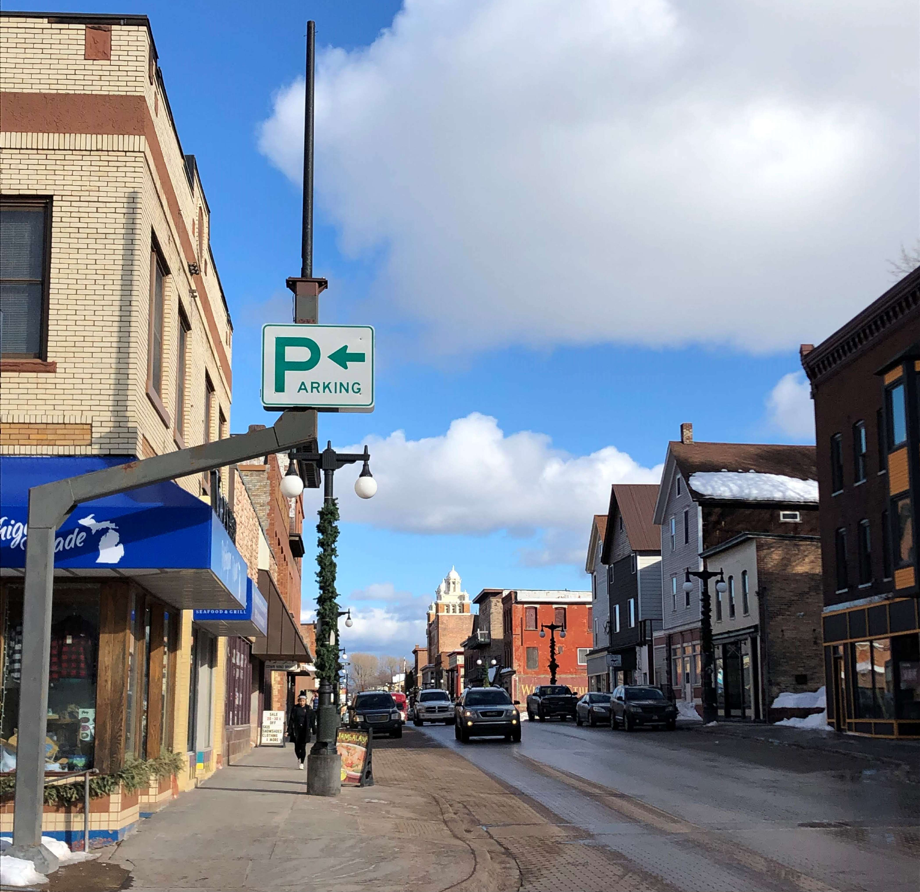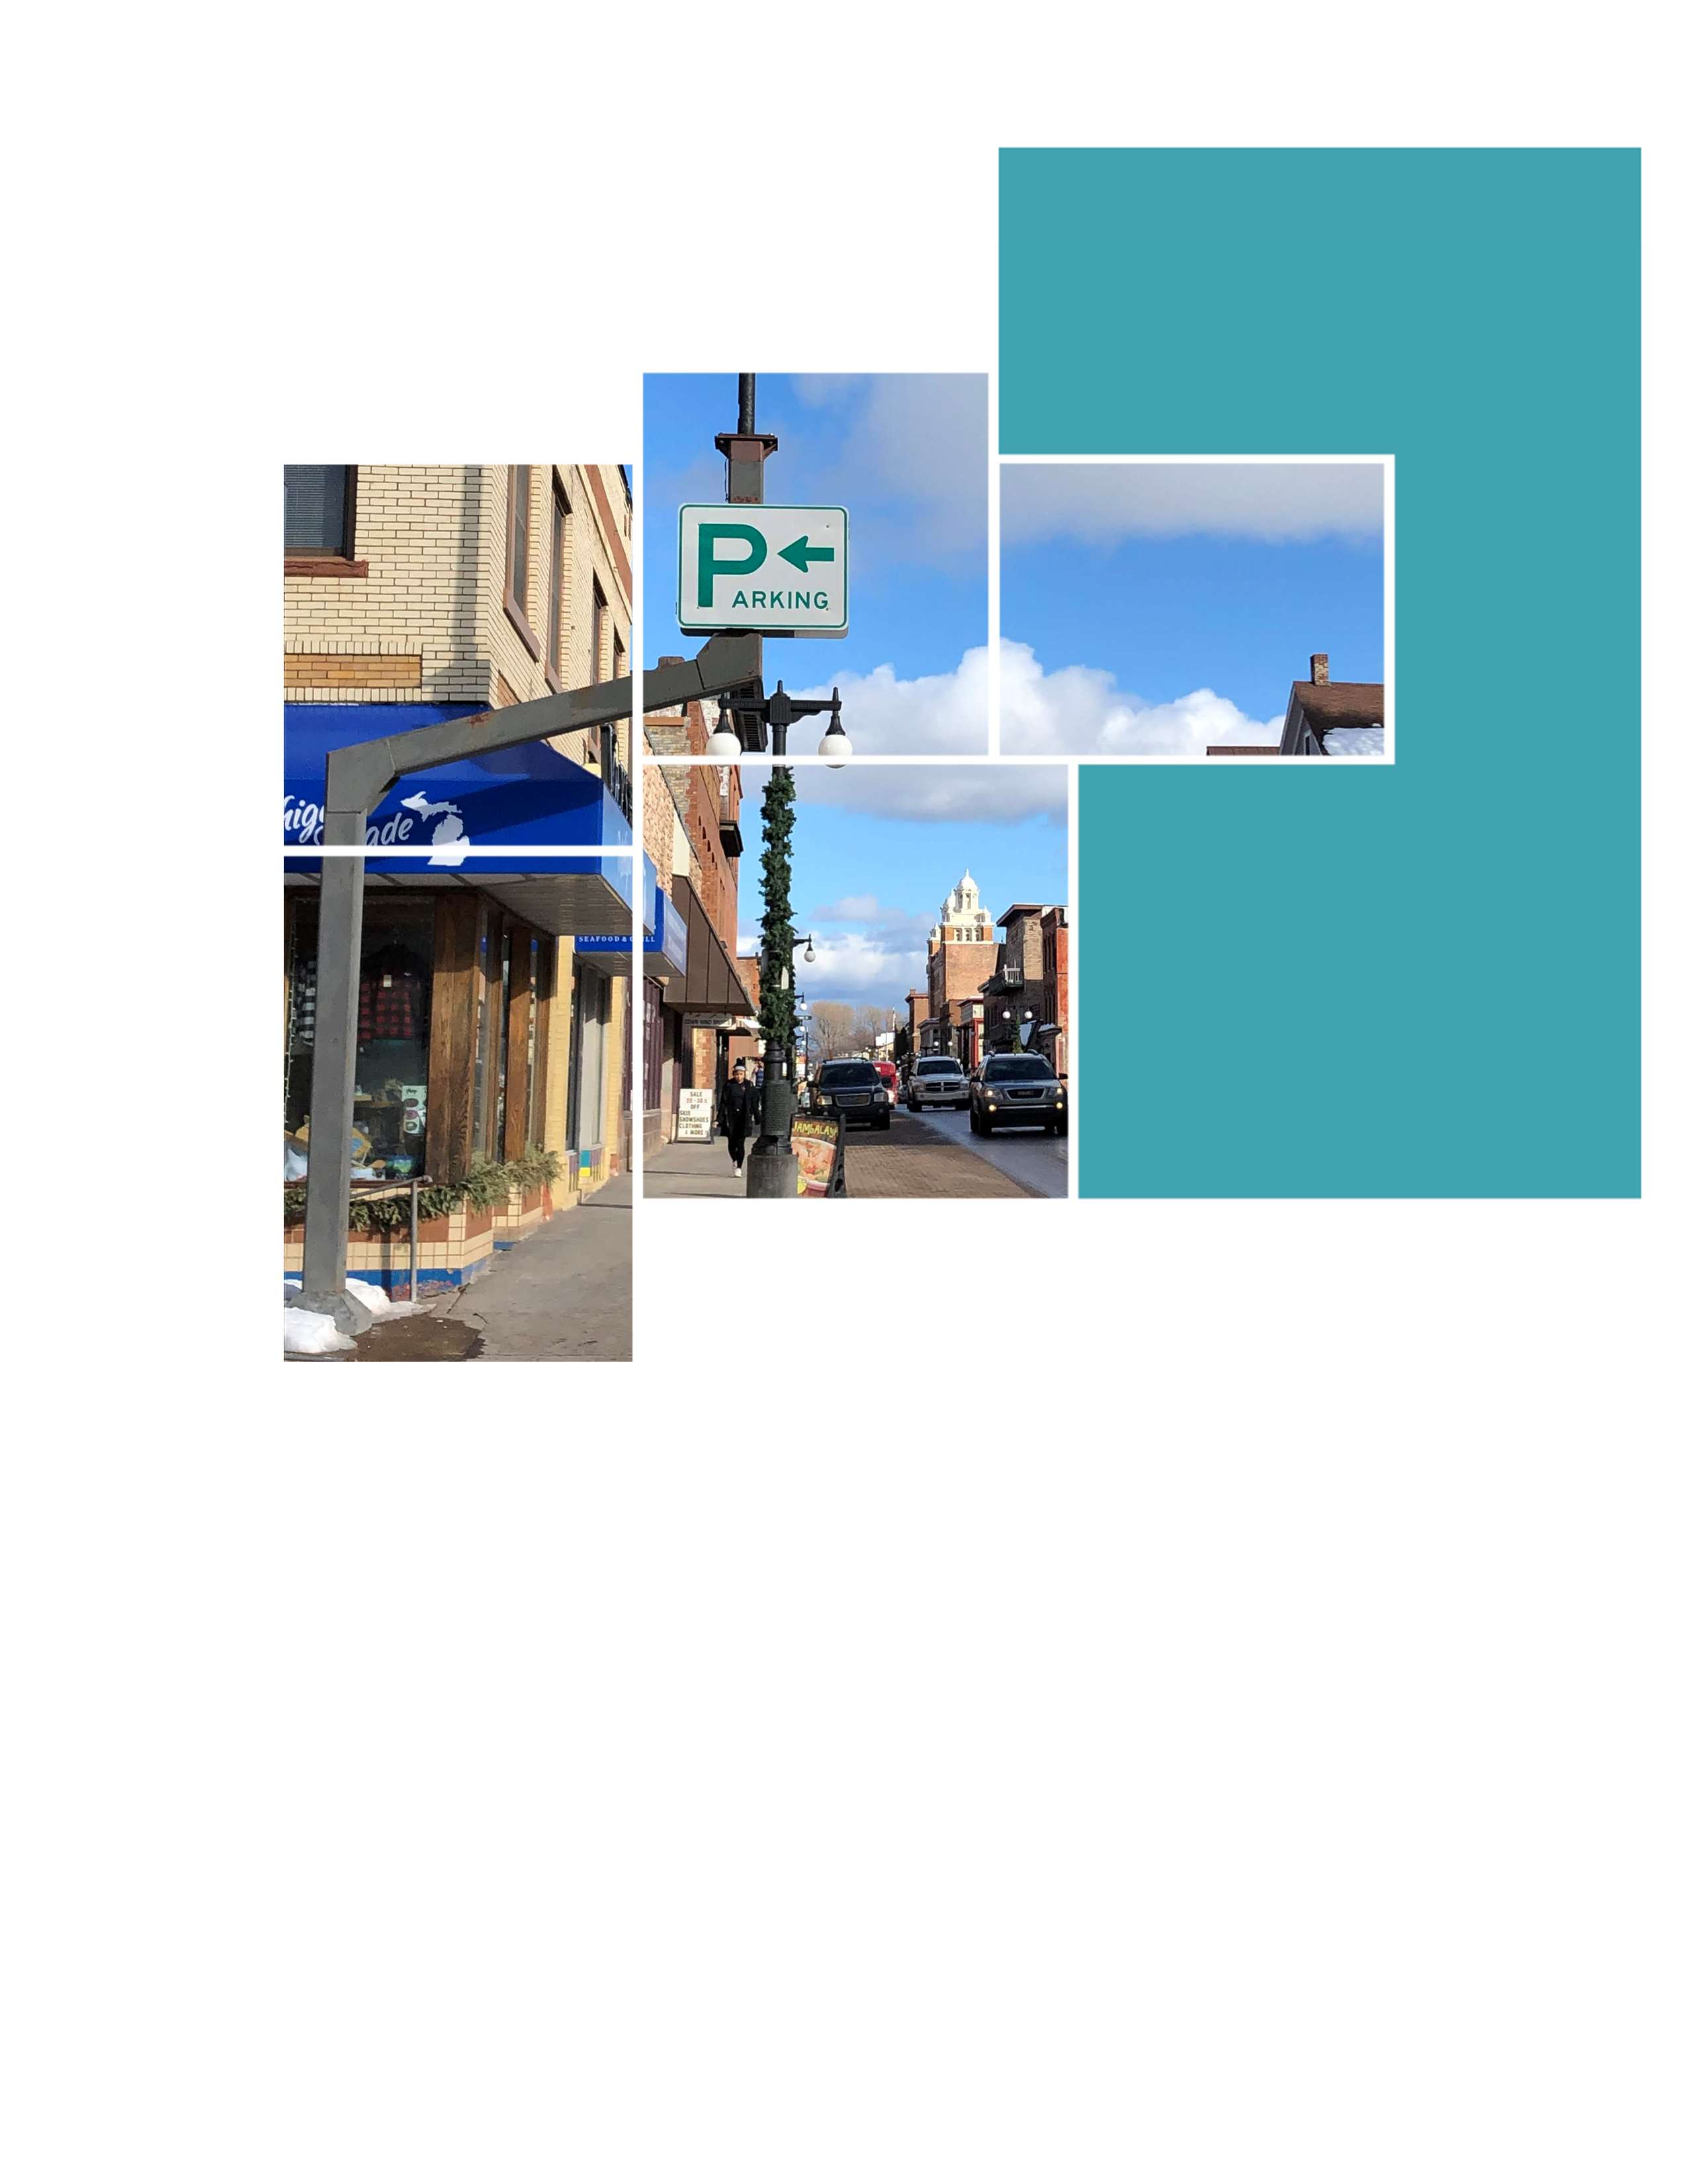

Downtown Parking Analysis

Houghton, Michigan

July 14th, 2020 *(Final Report)*

Prepared for: Veridea Group and City of Houghton

CONTENTS

EXECUTIVE SUMMARY 3

INTRODUCTION 7

Project Understanding 7

EXISTING CONDITIONS 7

Study Area 7

Parking Supply 8

Parking Occupancy 10

Data Collection Observations 12

10:00 AM Parking Occupancy (Peak Demand period) 12

Parking Occupancy – Public Parking Only 13

FUTURE CONDITIONS 14

Shared Parking Needs Analysis 15

Land Use Units: Development Program Information 16

On-Site Future Parking Adequacy 17

PUBLIC ENGAGEMENT 20

Focus Groups and Public Forum 20

Online Survey 22

RECOMMENDATIONS 26

Increase Efficiency Through Shared Parking 26

Improve Wayfinding Signage 27

Increase Availability of Visitor Parking Informatioin 28

Create Uniformity in On-Street Time Limits 31

Downtown Walkability and Density 31

Employ Technology for Enforcement of Time Limits and Permit Parking 33

Over-Sized Parking for Trailers 34

Operating Methodology for a Potential Waterfront Parking Deck 35

Additional Operating Enhancements for Future Consideration 35

APPENDIX – MUNICIPAL BEST PRACTICES 37

STATEMENT OF LIMITING CONDITIONS 39

EXECUTIVE SUMMARY

The City of Houghton, along with a private development firm, chose to undertake this study of parking in downtown Houghton to achieve several goals including 1) gaining an understanding of current parking conditions in the downtown; 2) identifying the impact that new land uses could have on parking demand, and; 3) identifying ways to improve parking planning, policy, and operations in downtown.

Within the downtown study area bounded by the Keweenaw Waterway to the north, Franklin Street to the east, Montezuma Avenue to the south, and Kestner Waterfront Park to the west, there are currently approximately 1,587 parking spaces – 1,233 in off-street parking decks and surface lots and 354 in on-street spaces. Of the total parking supply, approximately 1,063 spaces (67%) are public parking spaces, while the remaining 524 spaces (33%) are private and permit parking. Based on parking occupancy surveys conducted over the course of several days in February 2020, utilization of the existing parking inventory downtown peaks around 10:00 AM on a weekday, when 44% of the spaces are occupied by parked vehicles (698 occupied spaces). When looking at only the public parking supply (i.e., removing any privately-owned parking or parking reserved for specific user groups), utilization also peaked at 10:00 AM, when 39% of the spaces were occupied (354 vehicles parked in 918 public spaces). While some off-street parking facilities and areas of on-street parking were highly utilized during the peak parking demand period, especially on the east end of downtown, overall, there is currently a significant surplus of parking within the downtown as a whole.

As downtown Houghton continues to grow and redevelop in the future, there is concern among some in the community that additional parking demand, combined with the potential loss of existing spaces, will result in a shortage of parking. Using available information related to potential new development projects in downtown, projections of future parking demand were developed based on the Urban Land Institute’s Shared Parking methodology. Additionally, anticipated changes to the parking supply were identified and quantified. Based on this future parking supply and demand analysis, the proposed waterfront development in downtown is projected to generate between 124 to 219 additional parked vehicles in the area daily. The parking supply is sufficient to satisfy the future downtown parking needs, given the existing surplus of public parking supply east of the bridge, as well as the additional parking supply to be constructed as part of the proposed development. Future parking conditions are shown in Figures 1 and 2 for two scenarios that indicate parking adequacy of 213 and 164 spaces, respectively.

Executive Summary Figure 1: Downtown Houghton Projected Parking Adequacy – High Case

Summary

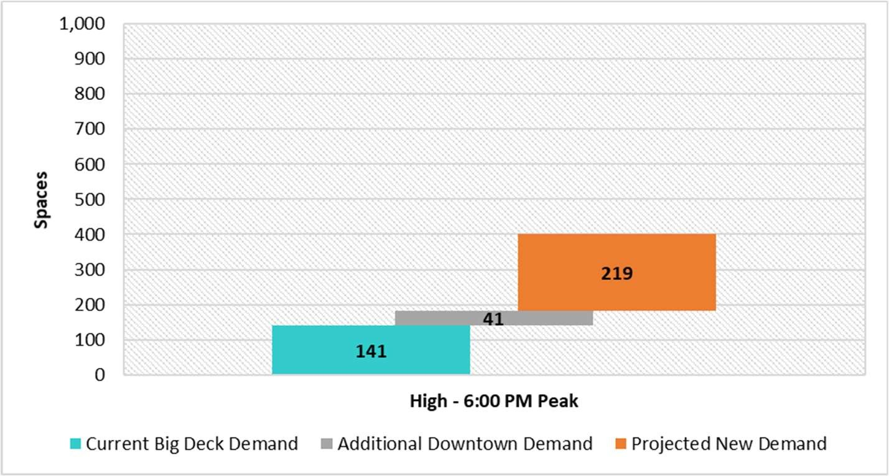

614 total public spaces

213-space

adequacy

High

6:00 PM Peak Demand 219 Space New Demand 213 Space Surplus

614 Space public inventory

*Source: Walker Consultants, 2020*

Executive Summary Figure 2: Downtown Houghton Projected Parking Adequacy – Low Case

Summary

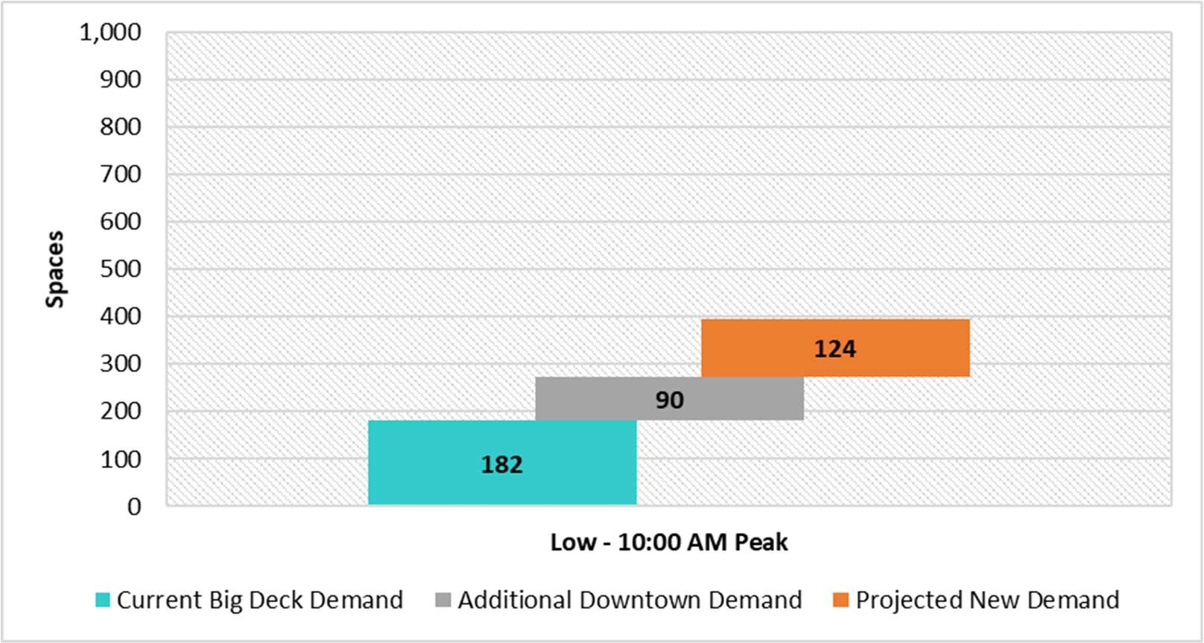

560 total public spaces

164-space

adequacy

Low

10:00 AM Peak Demand 124 Space New Demand 164 Space Surplus

560 Space public inventory

*Source: Walker Consultants, 2020*

At the new development site, a parking garage with a design capacity of 360 spaces is projected to satisfy the demand for a “High Case” planning scenario, while a garage with a design capacity of 306 spaces is projected to satisfy the demand for a “Low Case” planning scenario. Projected parking demand by time of day for both planning scenarios is presented in the following two Exhibits:

Executive Summary Figure 3: High Case Parking Demand – Time of Day Analysis

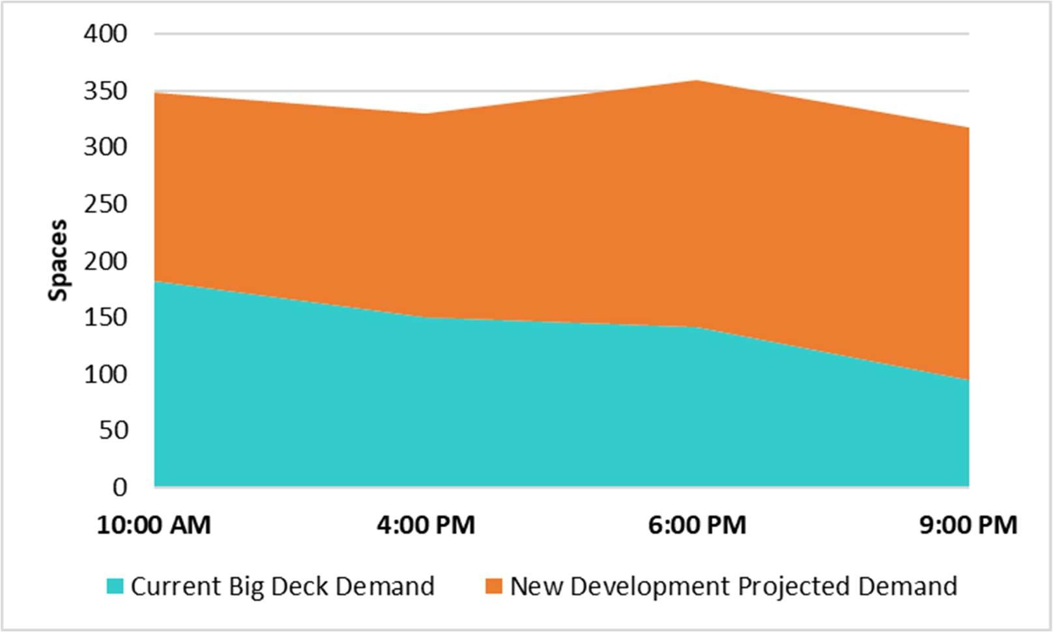

Peak Demand / Design Capacity = 360 Spaces

*Source: Walker Consultants, 2020*

Executive Summary Figure 4: Low Case Parking Demand – Time of Day Analysis

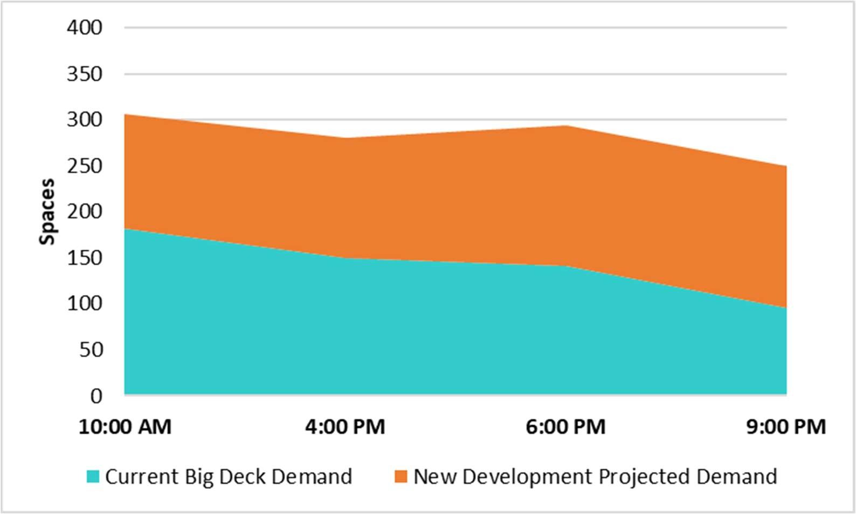

Peak Demand / Design Capacity = 306 Spaces

*Source: Walker Consultants, 2020*

The following is a list of key factors that impact design capacity for both planning scenarios:

* Historically, up to 95 vehicles park overnight (or are stored in some cases), at this prime waterfront site. Generally, Walker does not recommend utilizing prime downtown real estate for long-term vehicle parking. However, at the direction of the City, the analysis assumes that overnight vehicle storage will continue at this location in the future.
* It was assumed that typical weekday levels of retail/restaurant parkers would utilize a new parking garage on the waterfront to access businesses along Shelden Avenue during the daytime and early evening hours.
* Presently, during peak demand times, 35 percent of the remaining public (non-permit) off-street spaces, east of the lift bridge, are utilized. This equates to 65 percent of the remaining public spaces in downtown Houghton being available for transient and, if necessary, permit parkers. When including on-street spaces to the downtown public parking system total, only 32 percent of all remaining public spaces are utilized east of the bridge, with 68 percent (412 total spaces) available.
* Alternative off-street parking facilities may need to be utilized for overnight permit parking, in order to reduce the number of parking spaces needed on the waterfront. Additionally, a limit on overnight permit sales may need to be implemented.
* During the busiest peak demand times (busiest summer weekends), particularly during early evening hours, the proposed garage could fill, and some transient parkers may need to park on-street or in alternative off- street parking facilities. As shown in the above Exhibits, overnight demand “cushions” of 42 and 56 spaces, depending on scenario, are projected.
* Parking facilities and long-term vehicle storage are often best placed in peripheral locations or efficiently operated shared parking facilities, and in Houghton’s case ideally away from the waterfront. The current location of the Big Deck restricts access to the Keweenaw Waterway, which is one of downtown Houghton’s greatest natural assets.

In addition to analyzing the existing and potential future parking supply and demand in downtown Houghton, the City’s existing parking operation was also evaluated, with the goal of helping the City maximize the existing parking resources within downtown. As a result of this evaluation, it is recommended that the City:

* Seek to utilize private parking facilities for public parking during off-peak times through formalized shared parking agreements with private owners;
* Improve wayfinding signage on the approaches to downtown to make public parking easier to locate, especially for infrequent or first-time visitors;
* Increase the amount and usefulness of parking information available to the public on the City’s website;
* Create uniformity in on-street parking time limits throughout downtown, while adding loading zone spaces;
* Enhance and promote the walkability of downtown Houghton;
* Employ technology to increase the efficiency of the parking enforcement operation, and;
* Establish additional locations for over-sized vehicle parking.

INTRODUCTION

The City of Houghton, Michigan (“the City”), and Veridea Group (“Veridea”) retained Walker Consultants (“Walker”) to provide parking consulting services regarding the downtown Houghton, Michigan parking system. The goal of the engagement is to review the current parking conditions in the downtown, identify the impact that new land uses could have on parking demand, and provide guidance and recommendations regarding future parking planning policy and operations. This report provides a summary of Walker’s results and recommendations.

PROJECT UNDERSTANDING

The current parking system includes approximately 1,587 spaces in downtown Houghton. The system is a network of resources and policies designed in partnership with the community to provide citizens, visitors, and businesses equitable access to goods and services in downtown. Downtown Houghton is home to a variety of businesses, events, residents, and places of interest. Plans for additional mixed-use development in the downtown area will impact the public parking system. For this reason, there is a need for the City to proactively plan for future development and adjust parking infrastructure accordingly, and reexamine parking and mobility policies to ensure continued support of the current and emerging developments.

This report provides the City the opportunity to develop a downtown parking plan that will help modernize and equip the public parking system to serve the community, plan for the appropriate amount of supply, and set policy that maximizes the use of public resources.

EXISTING CONDITIONS STUDY AREA

For this project, the study area is defined as the geographical area generally bound by the Keweenaw Waterway to the north; Franklin Street to the east; Montezuma Avenue to the south; and Kestner Waterfront Park to the west. The study area represents the majority of downtown Houghton and all on-street and publicly available off-street parking facilities that are within that area, as well as any significant private parking supply. The study area was further divided into 18 blocks to measure and evaluate the local parking conditions more precisely.

Figure 1 highlights the project study area and the block-numbering system. Please note that for consistency the block numbers match those found on the City of Houghton Parking Map provided to Walker by U.P. Engineers and Architects, Inc.

Figure 1: Study Area

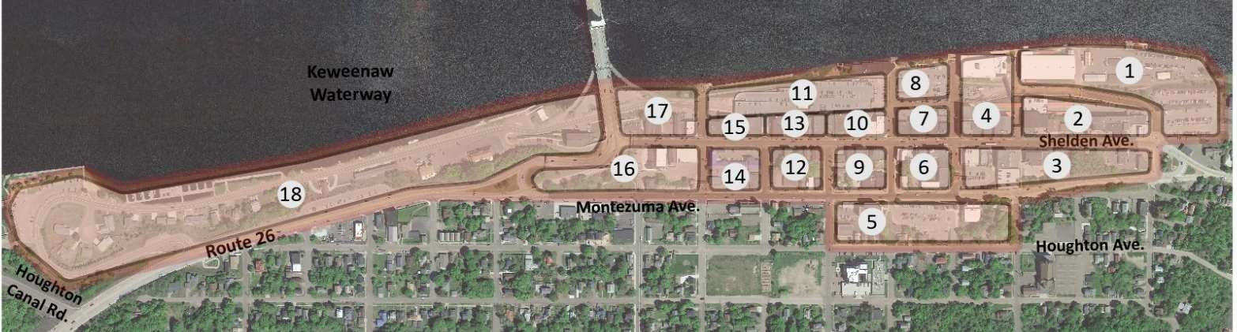

*Source: Google Earth, Walker Consultants, 2020*

PARKING SUPPLY

**Franklin St.**

The current publicly available on- and off-street parking supply, as well as much of the private parking supply, was inventoried (parking spaces counted) by Walker on Monday, February 24, 2020. Private driveways, alleyways, and small parking areas with one (1) to four (4) spaces were not inventoried. Based on this inventory, it was determined that a total of 1,587± parking spaces are located in the study area, of which 1,233 or 78 percent are off-street spaces. Eighteen (18) city blocks, five (5) parking decks, and 17 surface lots were inventoried as part of the analysis.

The off-street parking inventory is presented by block and facility in Table 1. Parking inventory type and designation is presented in Figure 2. The on-street inventory is presented later in this report in Table 3.

Table 1: Off-Street Parking Supply

|  |  |  |  |
| --- | --- | --- | --- |
| **Parking Facility** | | | **Inventory** |
| **Block #** | **Facility ID** | **Facility Name** | **Total Spaces** |
| **1** | **A** | Franklin Square Permit Lot | **44** |
| **1** | **B** | Franklin Square Transient Lot | **29** |
| **2** | **A** | Magnuson Lot | **50** |
| **2** | **B** | Lakeshore Center Parking | **93** |
| **2** | **C** | Subway Deck | **49** |
| **2** | **D** | Subway Lot | **10** |
| **3** | **A** | Vault Deck | **35** |
| **3** | **B** | UP Engineering Deck | **74** |
| **4** | **A** | Lakeshore Center Lot | **13** |
| **4** | **B** | Gazette Apartments Lot | **17** |
| **5** | **A** | Grace United Church Lot | **70** |
| **8** | **A** | Waterfront Surface Lot (Area #2) | **57** |
| **11** | **A** | Big Deck | **380** |
| **14** | **A** | Quality Inn Lot | **17** |
| **16** | **A** | Ambassador Deck | **41** |
| **16** | **B** | Veteran's Park Lot | **9** |
| **17** | **A** | Bridge Lot | **10** |
| **17** | **B** | Under Bridge Lot | **31** |
| **18** | **A** | Memorial Drive Private Lot | **17** |
| **18** | **B** | Roy's Bakery Lot | **50** |
| **18** | **C** | City Park and Ride Lot | **35** |
| **18** | **D** | Kestner Park Lot | **102** |
| **Total** | | | **1,233** |

*Source: Walker Consultants, 2020*

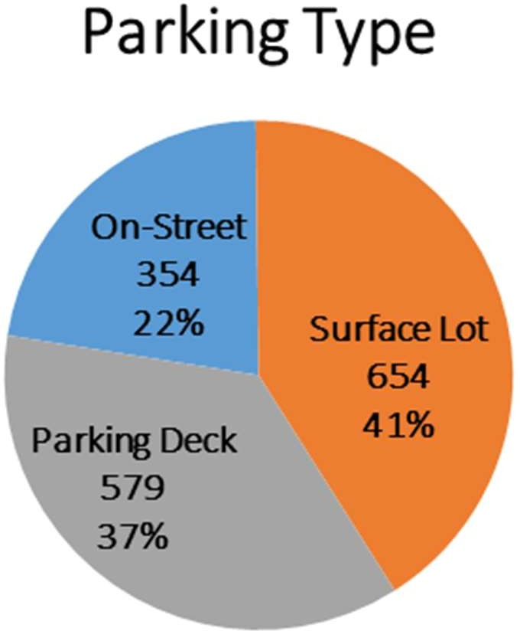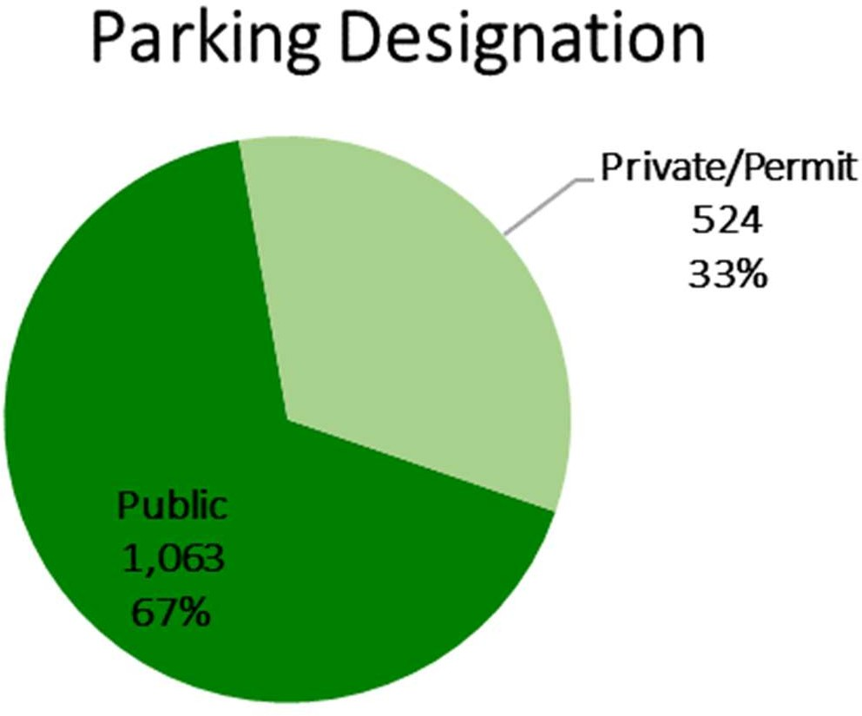Figure 2: Parking System – Supply Analytics

*Source: Walker Consultants, 2020*

Figure 3 presents the various off-street parking facilities by user-type and restrictions. Please note these are the general restrictions for each facility and additional, minor restrictions and user-types exist at some of the facilities. The number attached to each facility label corresponds to block number, as provided in Figure 1.

Figure 3: Off-Street Facilities by User Type

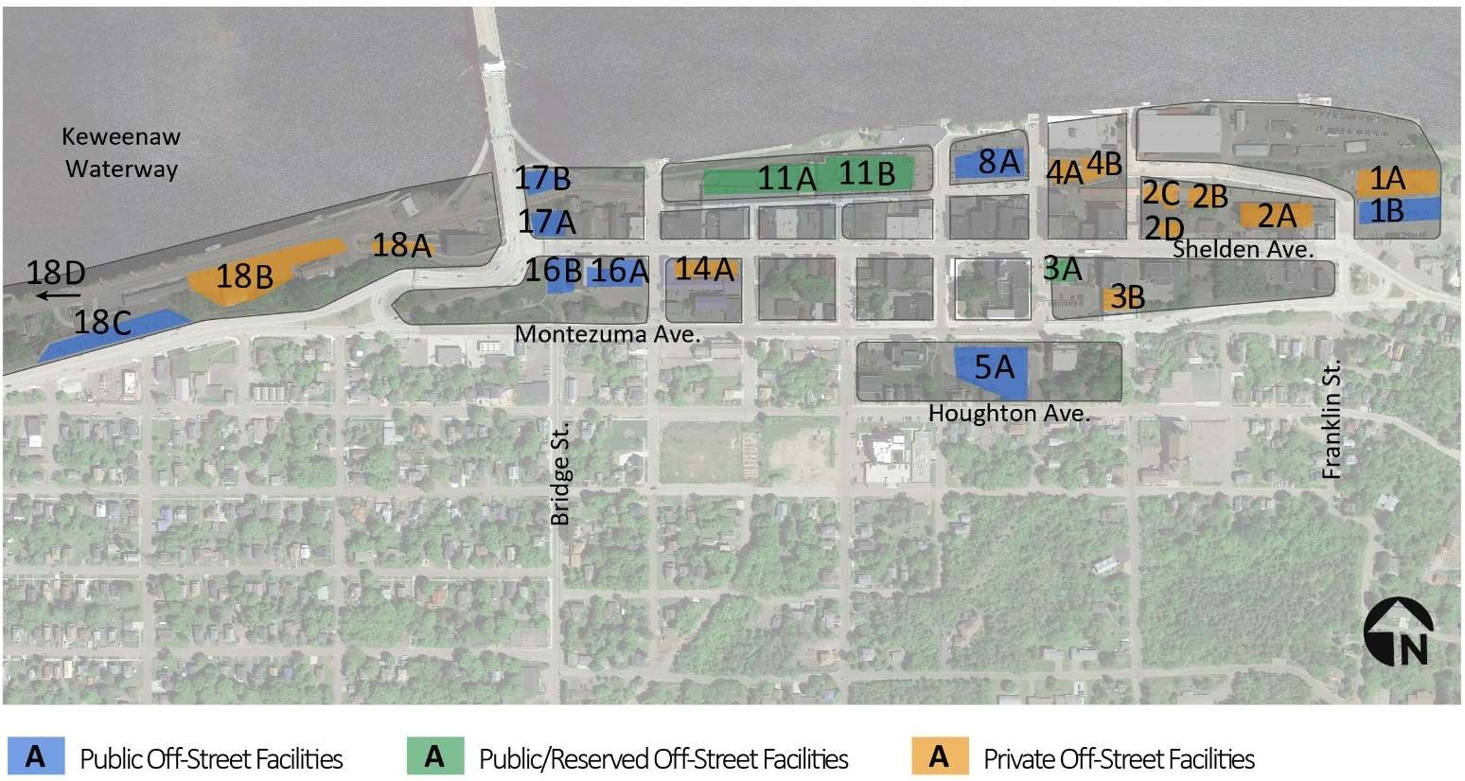

*Source: Google Earth, Walker Consultants, 2020*

PARKING OCCUPANCY

Walker conducted parking occupancy counts (vehicles parked in spaces) in the study area during a typical business day (Tuesday, February 25, 2020). Occupancy counts were conducted three (3) times during the following periods:

* + Morning starting at 10:00 AM
  + Afternoon starting at 4:00 PM
  + Evening starting at 6:00 PM

A fourth parking occupancy count, at 2:00 PM, was to be conducted during Walker’s second site visit. However, a second site-visit was not feasible due to the 2020 COVID-19 outbreak. This count is not essential to the success of the study and was only intended to provide additional background data for the analysis. In addition to the full downtown counts, parking occupancy spot checks were performed on Monday, February 24 and Wednesday, February 26 to verify the occupancy survey results. No anomalies in the data were found during these spot checks and occupancies largely matched those found on Tuesday.

Off-street occupancy data is presented by block and facility type in Table 2, and on-street occupancy data, by block face (i.e. one side of a city block), is presented in Table 3. The color coding used to highlight incremental parking occupancy levels is as follows:

* 0-49.9% occupancy – Green
* 50-69.9% occupancy – Yellow
* 70-84.9% occupancy – Orange
* 85%+ occupancy – Red

Table 2: Off-Street Parking Occupancy

|  |  |  |  |  |  |  |  |  |  |
| --- | --- | --- | --- | --- | --- | --- | --- | --- | --- |
| **Parking Facility** | | | **Inventory** | **Occupancy Counts** | | | | | |
| **Block #** | **Facility ID** | **Facility Name** | **Total Spaces** | **10:00 AM** | **Occ. %** | **4:00 PM** | **Occ. %** | **6:00 PM** | **Occ. %** |
| **1** | **A** | Franklin Square Permit Lot | **44** | 38 | 86% | 31 | 70% | 12 | 27% |
| **1** | **B** | Franklin Square Transient Lot | **29** | 24 | 83% | 16 | 55% | 3 | 10% |
| **2** | **A** | Magnuson Lot | **50** | 23 | 46% | 19 | 38% | 33 | 66% |
| **2** | **B** | Lakeshore Center Parking | **93** | 64 | 69% | 38 | 41% | 13 | 14% |
| **2** | **C** | Subway Deck | **49** | 30 | 61% | 26 | 53% | 7 | 14% |
| **2** | **D** | Subway Lot | **10** | 3 | 30% | 4 | 40% | 0 | 0% |
| **3** | **A** | Vault Deck | **35** | 12 | 34% | 8 | 23% | 4 | 11% |
| **3** | **B** | UP Engineering Deck | **74** | 58 | 78% | 42 | 57% | 27 | 36% |
| **4** | **A** | Lakeshore Center Lot | **13** | 13 | 100% | 7 | 54% | 6 | 46% |
| **4** | **B** | Gazette Apartments Lot | **17** | 13 | 76% | 9 | 53% | 14 | 82% |
| **5** | **A** | Grace United Church Lot | **70** | 21 | 30% | 6 | 9% | 1 | 1% |
| **8** | **A** | Waterfront Surface Lot (Area #2) | **57** | 35 | 61% | 25 | 44% | 24 | 42% |
| **11** | **A** | Big Deck | **380** | 182 | 48% | 150 | 39% | 141 | 37% |
| **14** | **A** | Quality Inn Lot | **17** | 7 | 41% | 16 | 94% | 17 | 100% |
| **16** | **A** | Ambassador Deck | **41** | 5 | 12% | 6 | 15% | 8 | 20% |
| **16** | **B** | Veteran's Park Lot | **9** | 0 | 0% | 0 | 0% | 0 | 0% |
| **17** | **A** | Bridge Lot | **10** | 0 | 0% | 0 | 0% | 2 | 20% |
| **17** | **B** | Under Bridge Lot | **31** | 1 | 3% | 2 | 6% | 3 | 10% |
| **18** | **A** | Memorial Drive Private Lot | **17** | 13 | 76% | 13 | 76% | 0 | 0% |
| **18** | **B** | Roy's Bakery Lot | **50** | 35 | 70% | 17 | 34% | 8 | 16% |
| **18** | **C** | MDOT Park and Ride Lot | **35** | 15 | 43% | 10 | 29% | 10 | 29% |
| **18** | **D** | Kestner Park Lot | **102** | 0 | 0% | 2 | 2% | 3 | 3% |
| **Total** | | | **1,233** | **592** | **48%** | **447** | **36%** | **336** | **27%** |

*Source: Walker Consultants, 2020*

Table 3: On-Street Parking Occupancy

|  |  |  |  |  |  |  |  |  |  |  |  |
| --- | --- | --- | --- | --- | --- | --- | --- | --- | --- | --- | --- |
| **Occupancy Key** | | **On- Street Block** | | **Inventory** |  | **Occ upancy Counts** | | | | | |
| **Block #** | **Face** | **Total Spaces** |  | **10 :0 0 AM** | **Occ. %** | **4 :00 P M** | **Occ. %** | **6 :00 P M** | **Occ. %** |
| 0-49.9 %  50-69.9 %  70-84.9 %  85-100 %  No Parking |  | **1** | S | **2 0** |  | 3 | 15% | 4 | 20% | 7 | 35% |
|  | **1** | W | **6** |  | 1 | 17% | 3 | 50% | 8 | 133% |
| **2** | N | **0** |  |  | - |  | - |  | - |
|  | **2** | E | **0** |  |  | - |  | - |  | - |
|  | **2** | S | **1 1** |  | 9 | 82% | 4 | 36% | 2 | 18% |
| **2** | W | **7** |  | 3 | 43% | 3 | 43% | 3 | 43% |
|  | **3** | N | **2 6** |  | 5 | 19% | 2 | 8% | 2 | 8% |
|  | | **3** | E | **0** |  |  | - |  | - |  | - |
| **3** | S | **0** |  |  | - |  | - |  | - |
| **3** | W | **0** |  |  | - |  | - |  | - |
| **3** | W (Inside) | **9** |  | 0 | 0% | 0 | 0% | 0 | 0% |
| **4** | N | **2** |  | 2 | 100% | 1 | 50% | 1 | 50% |
| **4** | E (Inside) | **3** |  | 3 | 100% | 3 | 100% | 8 | 267% |
| **4** | E | **7** |  | 3 | 43% | 3 | 43% | 3 | 43% |
| **4** | S | **1 0** |  | 4 | 40% | 3 | 30% | 3 | 30% |
| **4** | W | **7** |  | 3 | 43% | 6 | 86% | 5 | 71% |
| **5** | N | **0** |  | 0 | - | 0 | - | 0 | - |
| **6** | N | **6** |  | 1 | 17% | 2 | 33% | 1 | 17% |
| **6** | E | **5** |  | 1 | 20% | 3 | 60% | 1 | 20% |
| **6** | S | **3** |  | 2 | 67% | 1 | 33% | 0 | 0% |
| **6** | W | **5** |  | 3 | 60% | 3 | 60% | 3 | 60% |
| **7** | N | **5** |  | 1 | 20% | 1 | 20% | 0 | 0% |
| **7** | E | **0** |  |  | - |  | - |  | - |
| **7** | S | **5** |  | 2 | 40% | 1 | 20% | 3 | 60% |
| **7** | W | **0** |  |  | - |  | - |  | - |
| **8** | N | **2 4** |  | 18 | 75% | 1 | 4% | 2 | 8% |
| **8** | N (Across) | **1 9** |  | 12 | 63% | 8 | 42% | 6 | 32% |
| **8** | E | **0** |  |  | - |  | - |  | - |
| **8** | S | **0** |  |  | - |  | - |  | - |
| **8** | W | **0** |  |  | - |  | - |  | - |
| **9** | N | **6** |  | 1 | 17% | 3 | 50% | 3 | 50% |
| **9** | E | **0** |  |  | - |  | - |  | - |
| **9** | S | **0** |  |  | - |  | - |  | - |
| **9** | W | **6** |  | 3 | 50% | 0 | 0% | 1 | 17% |
| **10** | N | **0** |  |  | - |  | - |  | - |
| **10** | E | **7** |  | 3 | 43% | 5 | 71% | 2 | 29% |
| **10** | S | **1 3** |  | 2 | 15% | 6 | 46% | 3 | 23% |
| **11** | E | **4** |  | 2 | 50% | 2 | 50% | 1 | 25% |
| **11** | S | **1 4** |  | 1 | 7% | 2 | 14% | 3 | 21% |
| **12** | N | **9** |  | 1 | 11% | 4 | 44% | 5 | 56% |
| **12** | E | **0** |  |  | - |  | - |  | - |
| **12** | S | **7** |  | 0 | 0% | 0 | 0% | 0 | 0% |
| **12** | W | **1 4** |  | 1 | 7% | 3 | 21% | 3 | 21% |
| **13** | N | **0** |  |  | - |  | - |  | - |
| **13** | S | **1 3** |  | 1 | 8% | 1 | 8% | 3 | 23% |
| **13** | W | **0** |  |  | - |  | - |  | - |
| **14** | N | **5** |  | 0 | 0% | 1 | 20% | 2 | 40% |
| **14** | E | **0** |  |  | - |  | - |  | - |
| **14** | S | **0** |  |  | - |  | - |  | - |
| **15** | N | **5** |  | 4 | 80% | 4 | 80% | 1 | 20% |
| **15** | E | **0** |  |  | - |  | - |  | - |
| **15** | S | **9** |  | 2 | 22% | 3 | 33% | 5 | 56% |
| **15** | W | **4** |  | 0 | 0% | 0 | 0% | 0 | 0% |
| **16** | N | **7** |  | 3 | 43% | 0 | 0% | 3 | 43% |
| **16** | S | **0** |  |  | - |  | - |  | - |
| **16** | S (Inside) | **2 8** |  | 0 | 0% | 1 | 4% | 0 | 0% |
| **16** | W | **1 0** |  | 6 | 60% | 5 | 50% | 5 | 50% |
| **17** | N | **2** |  | 0 | 0% | 0 | 0% | 0 | 0% |
| **17** | E | **3** |  | 0 | 0% | 2 | 67% | 2 | 67% |
| **17** | S | **8** |  | 0 | 0% | 2 | 25% | 4 | 50% |
| **18** | N | **0** |  |  | - |  | - |  | - |
| **18** | E | **0** |  |  | - |  | - |  | - |
| **18** | S | **0** |  |  | - |  | - |  | - |
| **18** | W | **0** |  |  | - |  | - |  | - |
| **Total** | | **35 4** |  | **10 6** | **30 %** | **9 6** | **2 7 %** | **1 04** | **29 %** |

*Source: Walker Consultants, 2020*

DATA COLLECTION OBSERVATIONS

* *Time of Year and Weather:* Walker’s data collection occurred on a sunny, mid-Winter day with 40-degree temperatures, before most spring break vacations and before the impacts of the COVID-19 pandemic were felt in Houghton. This timeframe likely resulted in typical weekday demand patterns.
* On-street parking was readily available, even during the lunch and evening rush periods.
* Specific off-street facilities saw higher demand periods, particularly the Franklin Square lots, the Michigan Tech lot on Lakeshore Drive, and the lot in front of the Quality Inn. Additionally, the surface lot surrounding Roy’s Bakery was heavily utilized during the morning occupancy count.
* Peak parking demand occurred during the 10:00 AM count for both on- and off-street parking facilities.
* Parking demand slowly decreased throughout the course of the afternoon.
* The Big Deck and the Ambassador Deck were underutilized throughout the day. Table 4: Parking Occupancy, On- and Off-Street Summary

**O ccupancy Key**

0-49.9 %

50-69.9 %

70-84.9 %

85-100 %

**Parking Type**

**Parking**

**Weekday Parking Occupancy**

Peak Demand

|  |  |  |  |  |  |  |  |  |  |
| --- | --- | --- | --- | --- | --- | --- | --- | --- | --- |
|  |  | **Inventory** | **10 :00 AM** | **Oc c . %** | **4 :00 PM** | **Occ. %** | **6 :00 PM** | **Occ. %** |  |
| **On- Street** | 354 | 106 | 30% | 96 | 27% | 104 | 29% |  |
| **Off-Street** | 1,233 | 592 | 48% | 447 | 36% | 336 | 27% |  |
| **Total** | **1 ,587** | **698** | **44 %** | **543** | **34 %** | **440** | **28 %** |  |
|  |  |  |  |  |  |  |  |  |  |

*Source: Walker Consultants, 2020*

10:00 AM PARKING OCCUPANCY (PEAK DEMAND PERIOD)

As shown in Table 4, peak parking occupancy (peak demand) occurred during the 10:00 AM observation with 698± vehicles parked within the study area; 106 of those cars were parked on-street, while 592 were parked off-street. The combined total equates to a 44 percent parking occupancy rate (698 parked vehicles in 1,587 spaces). Both on- street (30%) and off-street (48%) facilities experienced peak demand during the 10:00 AM observation period. Off- street demand slowly dropped off from there (48% to 27%), while on-street demand saw a slight increase from 4:00 PM to 6:00 PM (27% to 29%). This parking demand pattern could be partially due to the dinner rush or residents and employees running errands after work and parking on Shelden Avenue or the side streets.

The parking occupancy data in Table 4 represents all cars parked in on-street spaces and public and private off- street facilities during the three observation periods. Figure 4 provides a parking occupancy “heat” map, with the various colors corresponding to the occupancy key found below the map (and in the occupancy tables above). The darker the color, the more highly utilized the parking facility (or street).

Figure 4: 10:00 AM Parking Occupancy (Peak Demand)

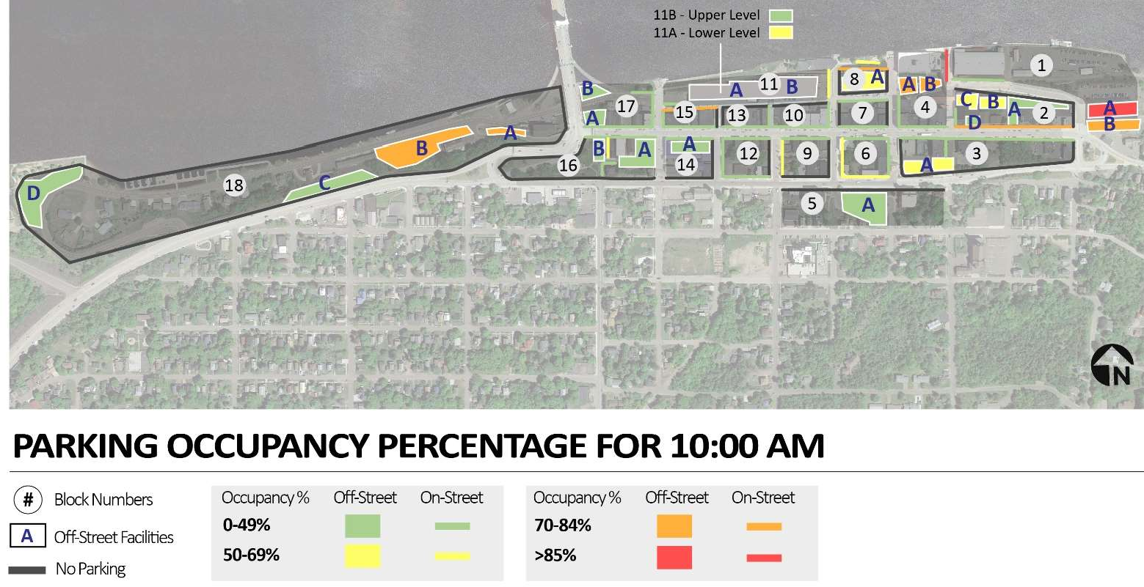

*Source: Google Earth, Walker Consultants, 2020*

PARKING OCCUPANCY – PUBLIC PARKING ONLY

Walker also performed an occupancy analysis for public parking-only spaces in downtown Houghton, meaning those spaces that are owned and operated by the City for public use (residents, visitors, business patrons, etc.). Please note that while the Kestner Park Lot and the Michigan Department of Transportation Park and Ride Lot are public facilities, they were not included in this analysis as they are too far removed from the core downtown area and are not designed to contribute to the downtown parking system. The results of this analysis for off-street facilities, and a system-wide summary of both on- and off-street facilities, are provided in Tables 5 and 6.

Table 5: Off-Street Parking Occupancy (Public Spaces Only)

|  |  |  |  |  |  |  |  |  |  |
| --- | --- | --- | --- | --- | --- | --- | --- | --- | --- |
| **Parking Facility** | | | **Inventory** | **Occupancy Counts** | | | | | |
| **Block #** | **Facility ID** | **Facility Name** | **Total Spaces** | **10:00 AM** | **Occ. %** | **4:00 PM** | **Occ. %** | **6:00 PM** | **Occ. %** |
| **1** | **B** | Franklin Square Transient Lot | **29** | 24 | 83% | 16 | 55% | 3 | 10% |
| **3** | **A** | Vault Deck | **7** | 4 | 57% | 3 | 43% | 0 | 0% |
| **5** | **A** | Grace United Church Lot | **70** | 21 | 30% | 6 | 9% | 1 | 1% |
| **8** | **A** | Waterfront Surface Lot (Area #2) | **57** | 35 | 61% | 25 | 44% | 24 | 42% |
| **11** | **A** | Big Deck (Lower/Ground Level) | **141** | 89 | 63% | 70 | 50% | 85 | 60% |
| **11** | **B** | Big Deck (Upper Level) | **169** | 69 | 41% | 57 | 34% | 48 | 28% |
| **16** | **A** | Ambassador Deck | **41** | 5 | 12% | 6 | 15% | 8 | 20% |
| **16** | **B** | Veteran's Park Lot | **9** | 0 | 0% | 0 | 0% | 0 | 0% |
| **17** | **A** | Bridge Lot | **10** | 0 | 0% | 0 | 0% | 2 | 20% |
| **17** | **B** | Under Bridge Lot | **31** | 1 | 3% | 2 | 6% | 3 | 10% |
| **Total** | | | **564** | **248** | **44%** | **185** | **33%** | **174** | **31%** |

*Source: Walker Consultants, 2020*

Table 6: Parking Occupancy, On- and Off-Street Summary (Public Spaces Only)

**O ccupan** 0-49.9 %

50-69.9 %

70-84.9 %

85-100 %

|  |  |  |  |  |  |  |  |  |  |
| --- | --- | --- | --- | --- | --- | --- | --- | --- | --- |
| **cy Key** | **Parking Type On-Street** | **Parking Inventory**  354 | Peak D  **10:00 AM**  106 | emand  **Occ. %** 30% | **Parking O 4:00 PM**  96 | **ccupancy Occ. %**  27% | **6:00 PM**  104 | **Occ. %** 29% |  |
|  | **Off-Street (Public)** | 564 | 248 | 44% | 185 | 33% | 174 | 31% |  |
|  | **Total** | **918** | **354** | **39%** | **281** | **31%** | **278** | **30%** |  |
|  |  |  |  |  |  |  |  |  |  |

*Source: Walker Consultants, 2020*

Similar to the entire parking inventory in downtown, peak parking occupancy (peak demand) in public-only spaces occurred during the 10:00 AM observation with 354± vehicles parked within the study area; 106 of those cars were parked on-street, while 248 were parked off-street. The on-street occupancy number did not change because all on-street spaces are considered public, as they are in the public right-of-way. In total, the City’s public parking spaces were 39 percent occupied at 10:00 AM (354 parked vehicles in 918 spaces). Both on-street (30%) and off- street (44%) facilities experienced peak demand during the 10:00 AM observation period. Like parking in the entirety of downtown, demand for off-street public spaces slowly dropped off after 10:00 AM (44% to 31%), while on-street demand saw the same increase from 4:00 PM to 6:00 PM (27% to 29%).

As shown above, *there is currently a surplus of parking in downtown Houghton*. During peak demand times on a weekday, only 30 percent of the on-street supply is occupied. Similarly, only 44 percent of the off-street supply is occupied. This means on-street spaces are 70 percent vacant and off-street spaces are 56 percent vacant. During the evening rush/dinner period, on-street parking is 29 percent occupied and off-street is 31 percent occupied. Furthermore, during all occupancy survey times, only three (3) off-street public facilities experienced occupancy levels above 50 percent (Franklin Square public lot, Vault Deck, and the Waterfront surface lot). Public spaces at the Big Deck were 50 percent occupied during the peak demand period. Of those three, only the Franklin Square lot experienced greater than 50 percent occupancy outside of the peak demand time of 10:00 AM. While there are occasional “hot spots” of parking demand, particularly on Shelden Avenue east of City Center, *the downtown as a whole is currently operating with a significant parking surplus*.

FUTURE CONDITIONS

Walker’s calculation of future parking demand is based on a thorough understanding of existing land uses in Houghton, as well as the known land uses that may enter or leave the defined study area. Walker, in conjunction with the Urban Land Institute (ULI), developed a Shared Parking Model to determine an appropriate and efficient number of parking spaces that are needed to serve a development (or group of developments) during typical peak demand (non-special event) conditions. Walker utilized the Shared Parking Model to project future parking space needs associated with a hypothetical waterfront mixed-use development in downtown Houghton. After completing the calculation of future parking needs associated with the potential new development, the results are added to the current observed downtown parking demand. This number is then compared to the existing (and any potential new) parking supply associated with a new development to determine the future parking adequacy.

SHARED PARKING NEEDS ANALYSIS

The City and Veridea asked Walker to prepare a Shared Parking needs analysis to ascertain the approximate number of parking spaces needed to effectively serve a waterfront, mixed-use development during peak-hour demand conditions downtown. Shared parking leverages the presence of complementary land uses on a site having different periods of peak parking demand, allowing for the sharing of parking spaces among uses in a mixed-use environment, in lieu of providing a minimum number of parking spaces for each individual use. For example, an office building can share parking with residential units because parking demand peaks in the day for the office workers and it peaks in the evening for the residents. This results in an opportunity to provide adequate parking without building more parking spaces than necessary for customers, employees, and residents. Shared parking commonly results in a reduction in the total need for parking spaces and in *more efficient use* of land dedicated to parking.

Shared parking is a cost-effective approach to addressing parking demand, which allows each parking space in a system or a development to be utilized to its maximum potential. This opens more land for uses other than parking and reduces overall development costs, which can have the parallel effect of lowering rents. The Keweenaw Waterway is one of downtown Houghton’s greatest natural assets. At present, a significant portion of the downtown parking supply is located along the waterfront and is not the highest and best use of the land. An increase in waterfront area dedicated to public green space, event/activity venues, and additional modes of transportation (walking, biking, snowmobiling) via a multi-use trail or community open space, would support the downtown character and quality of life. Further, other commercial land uses provide higher levels of revenue and a greater return than parking and long-term vehicle storage, which are often best placed in peripheral locations or efficiently operated shared parking facilities, as described in this section.

Walker’s Shared Parking Model is based on the Urban Land Institute (ULI) and International Council of Shopping Center’s (ICSC) Shared Parking publication. Walker led a team of consultants in writing the updated Shared Parking Third Edition and it features the most up-to-date parking demand model. The model projects the parking needs of a various types of development from 6:00 AM to 12:00 midnight on a typical weekday and a weekend day for every month of the year.

A Shared Parking needs analysis, in accordance with the 3rd Edition of the *Shared Parking* publication, is the generally accepted methodology for determining the appropriate parking supply for a mixed-use development. The ability to share parking spaces is the result of two conditions.

1. Variations in the accumulation of vehicles by hour, by day, or by season at the individual land uses. For example, office buildings have peak parking needs during the day on weekdays, restaurants have peak parking needs during the evening and weekends, and hotels and residential land uses have peak parking needs overnight.
2. Relationships among the land uses that result in visiting multiple land uses on the same auto trip. For example, a substantial percentage of patrons at one business (a restaurant for example) may be staying at the nearby hotel. This is referred to as the “effects of the captive market.” These patrons are already parking and contribute only once to the number of peak hour parkers. In other words, the parking demand ratio for individual land uses should be factored downward in proportion to the captive market received from neighboring land uses.

To determine a recommended parking supply for a potential waterfront development, which will likely include a mix of hotel, retail, restaurant, and residential land uses, Walker utilized these shared parking methodologies. The resulting recommended supply for the proposed project is based on the projected peak hour of design day parking demand. This does not represent the maximum ever generated by the development. In Walker’s experience, designing a parking system for the absolute peak busiest day of the year leads to overbuilding of parking spaces. Similarly, one does not build for an average day and have insufficient supply for the peak (if not multiple) hours on 50 percent of the days in a year. The peak in this analysis refers to the “design day” or “design hour,” one that occurs frequently enough to justify providing spaces for that level of parking activity. The 85th percentile of peak- hour parking occupancy observations is generally recommended by Shared Parking. Table 7 provides an illustrative view of the steps involved in the Shared Parking analysis.

Table 7: Steps of Shared Parking Analysis

Land Use Units

(Number of

rooms, retail X square

footage, etc.)

Standard or

Base Parking Generation Ratio

X Monthly X Hourly X Driving

Factor Factor Ratio

Non-

X Captive Ratio

= TOTAL

*Source: Walker Consultants, 2020*

List of Shared Parking Steps

1. Identification and Quantification of Project Land Use Components;
2. Application of Standard or Base Parking Generation Ratios;
3. Application of Presence Factors;
4. Application of Drive Ratio;
5. Application of Non-Captive Ratio; and
6. Total Weekday Recommended Number of Spaces from the Shared Parking Analysis.

LAND USE UNITS: DEVELOPMENT PROGRAM INFORMATION

Based upon information provided by Veridea, the potential development could contain restaurant, hotel, and residential land uses. Using industry standards and an understanding of the Houghton market, Walker made land use programing assumptions to input into the Shared Parking model. In order to provide a workable range of development assumptions, Walker created two scenarios – a high case and a low case. The high case represents a slightly larger development program, while the low case represents a slightly smaller program. The projected parking need results of the two scenarios are provided in Table 8 on the following page.

Table 8: Development Shared Parking Needs Analysis Results

|  |  |  |  |  |  |
| --- | --- | --- | --- | --- | --- |
|  | | **Projected Parking Demand 1** | | | |
| **Potential Development** | | **10:00 AM** | **4:00 PM** | **6:00 PM** | **9:00 PM** |
| **High Case** | Restaurant/Retail Shared  Parking | 64 | 76 | 109 | 108 |
| Residential/Hotel Reserved  Parking | 102 | 104 | 110 | 115 |
| **Total** |  | **166** | **180** | **219** | **223** |
| **Low Case** | Restaurant/Retail Shared  Parking | 45 | 49 | 68 | 66 |
| Residential/Hotel Reserved  Parking | 79 | 81 | 85 | 89 |
| **Total** |  | **124** | **130** | **153** | **155** |
| ***Note:*** *1 Projected parking demand only includes demand associated with the potential new development. Current parking demand is not included in these totals.* | | | | | |

*Source: Walker Consultants, 2020*

In both the high and low planning cases, stand-alone development parking demand is projected to peak at 9:00 PM on a weekday, with 223 total spaces projected to be needed in the high case (108 restaurant/retail public parking spaces plus 115 residential/hotel reserved spaces), and 155 spaces are projected to be needed in the low case (66 restaurant/retail public parking spaces plus 89 residential/hotel reserved spaces). Please note the proposed development programming is still being finalized and the resulting parking demand could be different than what is presented here.

As noted in the table, the projected demand quantities do not include current demand at the Big Deck, which would be displaced by the new development. Current parking demand associated with the Big Deck is included in the following section.

ON-SITE FUTURE PARKING ADEQUACY

After removing the displaced parking supply (the Big Deck) from the public parking system total, and adding the current parking demand from the Big Deck to the projected demand associated with the potential new development, a new projected parking demand results. Table 9 on the following page represents future projected parking demand for the high case scenario, while Table 10 represents projected parking demand for the low case.

Table 9: Development Site Future Projected Demand – High Case

|  |  |  |  |  |  |
| --- | --- | --- | --- | --- | --- |
| **Parking Fac il i ty** | | **Parking Demand** | | | |
| **Block #** | **Facility Name** | **10 :00 AM** | **4 :00 PM** | **6 :00 PM** | **9 :00 PM 1** |
| 11 | Big Deck Current Demand | 182 | 150 | 141 | 95 |
| 11 | New Development Potential Demand | 166 | 180 | 219 | 223 |
| **Projected Demand** | | **348** | **330** | **360** | **318** |
| **Notes:** 1 9:00 PM Current Demand assumes 95 overnight residential permit parkers. | | | | | |

*Source: Walker Consultants, 2020*

Table 10: Development Site Future Projected Demand – Low Case

|  |  |  |  |  |  |
| --- | --- | --- | --- | --- | --- |
| **Parking Fac il i ty** | | **Parking Demand** | | | |
| **Block #** | **Facility Name** | **10 :00 AM** | **4 :00 PM** | **6 :00 PM** | **9 :00 PM 1** |
| 11 | Big Deck Current Demand | 182 | 150 | 141 | 95 |
| 11 | New Development Potential Demand | 124 | 130 | 153 | 155 |
| **Projected Demand** | | **306** | **280** | **294** | **250** |
| **Notes:** 1 9:00 PM Current Demand assumes 95 overnight residential permit parkers. | | | | | |

*Source: Walker Consultants, 2020*

On-Site Peak Demand Projected to Occur at 6:00 PM

On-Site Peak Demand Projected to Occur at 10:00 AM

As shown in Tables 9 and 10 above, on-site parking demand is projected to need between 306 and 360 spaces, depending on planning scenario. For the High Case scenario, peak parking demand is expected to occur at 6:00 PM, with approximately 360 spaces needed to satisfy on-site parking demand (the development’s parking design capacity). For the Low Case scenario, peak parking demand is expected to occur at 10:00 AM, with approximately 306 spaces needed to satisfy on-site demand (design capacity). Included in the projected totals is an assumption that 95 overnight permit parking vehicles will need to be parked in the covered parking spaces offered by the proposed new garage.

Typically when designing a parking facility, a cushion of additional spaces (equal to five (5) to ten (10) percent of total design capacity) is applied to account for any infrequent surges in demand. The design capacity presented here, in conjunction with space availability in surrounding on-street areas and off-street facilities, is sufficient to accommodate these occasional surges in peak demand.

Please note the development’s parking design capacity has not been determined by the City or developer, and the design day capacities identified in this report are subject to change.

The following assumptions were made when projecting future parking demand in downtown Houghton:

* Outside of Big Deck parking demand (shown in Tables 9 and 10), it is assumed that permit parkers will continue to park in permit spaces, and private parking lots will continue to cater to their own patrons/residents. Further, it is assumed that the remaining publicly-available parking supply will continue to satisfy demand for each respective user group.
* The analysis does not include any on-street parking supply. It is assumed that patrons and visitors currently utilizing on-street spaces will continue to do so, and on-street demand patterns will remain largely consistent with existing demand patterns. In the rare case of spill-over demand from the potential new development, on-street spaces could see an increase in utilization (as could the Ambassador Deck and the small public surface lots at the intersection of Shelden Avenue and Memorial Drive/Michigan Route 26) during extreme peak demand conditions.
* After discussing with City officials, other than the subject potential mixed-use development along the waterfront, no other new developments were included in the future demand projections.

o Walker is aware that the Magnuson Franklin Square Inn was recently purchased and the new ownership group is converting it to a Hampton Inn (and adding 13 new rooms). It is our understanding, however, that the new owners are also adding 13 on-site parking spaces through lot reconfiguration. Further, the hotel has an agreement to use the City’s Franklin Square surface lot (and the National Park Service surface lot, in winter), as overflow parking, if needed.

* No organic growth rate was considered. Depending on the planning scenario, Walker will assign an organic growth rate to the future demand projection to account for an expanding economy, increased business and residential growth, and/or growing tourism visits. However, due to the pandemic of 2020, Walker assumed that demand levels will temporarily decline until eventually reverting to levels found in 2019.

Table 11 provides a summary of the future parking demand analysis, by development scenario, for the downtown public parking system as a whole. Similar to the development site itself, system-wide peak parking demand is projected to occur at 6:00 PM for the High Case with approximately 401 spaces needed to satisfy demand, and at 10:00 AM for the Low Case with approximately 396 spaces needed to satisfy demand throughout downtown.

Table 11: Future Parking Demand, Summary

|  |  |  |  |  |  |  |
| --- | --- | --- | --- | --- | --- | --- |
| **Scenario** | | | **Parking Inventory** | **Projected Peak**  **Demand** | **Parking Occ upancy** | ***Parking Surplus /***  ***(Deficit)*** |
| **High Case** | Peak Demand: 6:00 PM | New Development | 360 | 360 | 100% | *0* |
| Current Public System | 254 | 41 | 16% | *213* |
| **Total** |  |  | **614** | **401** | 65% | ***213*** |
| **Low Case** | Peak Demand: 10:00 AM | New Development | 306 | 306 | 100% | *0* |
| Current Public System | 254 | 90 | 35% | *164* |
| **Total** |  |  | **560** | **396** | 71% | ***164*** |

*Source: Walker Consultants, 2020*

As shown in the above tables, with the potential waterfront development’s attached parking deck, there is expected to be enough public parking supply to service the projected future parking demand in downtown Houghton. While the high case anticipates a 213-space surplus at the development and the low case anticipates a 164-space surplus, Walker recommends planning for a cushion to satisfy demand associated with any seasonal fluctuations throughout downtown (e.g. peak summer tourist season, snowfall covering portions of other parking facilities), expanded city- provided permit parking (if needed), and any special event demand needs, particularly overflow parking from events occurring at Dee Stadium. Based on Walker’s research and analysis, outside of the potential development, the construction of any additional surface or structured parking in the downtown area is not recommended at this time.

PUBLIC ENGAGEMENT

As is typical of our approach to municipal parking analyses, in addition to becoming acquainted with the downtown through firsthand exploration of the study area, review of prior studies and current data, and discussions with City staff, Walker also facilitated a series of discussions with downtown stakeholders, in order to gain firsthand insight into the parking issues/concerns of various user groups. Two (2) virtual focus group meetings and one (1) open public forum were held with various stakeholder groups, including:

* + Owners/managers of downtown retail stores and restaurants;
  + Employees of downtown stores and restaurants;
  + Downtown residents;
  + City staff members, and;
  + Members of the general public.

Additionally, Walker created an online survey that allowed the Houghton general public to answer questions and provide feedback regarding the downtown parking system.

FOCUS GROUPS AND PUBLIC FORUM

City staff offered Walker the use of their Zoom video web conference account for the facilitation of the public engagement meetings. Due to the COVID-19 pandemic, the city recently purchased the account to hold City Council, Planning Commission, and other official City meetings virtually. In discussions with the City Manager on how to best proceed in light of pandemic social distancing restrictions, he permitted Walker to use the city account to hold the focus group meetings and public forum/open house. In advance of the meetings, Walker developed a mission statement with some example questions that was sent to the City for their use when advertising the meetings (City website, local media articles, etc.). Ideally, this mission statement helped keep the meetings focused and the input relevant, particularly with the potentially large number of participants at the public forum. The three meetings were held on Wednesday, April 29:

* 9:00 AM – Downtown Business Owner and Resident Focus Group (30 attendees)
* 12:00 PM – City Staff Focus Group (12 attendees)
* 5:30 PM – Public Forum/Open House (55 attendees)

A fourth meeting (a standalone downtown resident focus group) was originally planned, but when the meetings shifted to a virtual format, City staff decided to combine it with downtown business owners for simplicity when sending out the invite weblinks. Summaries of each meeting are provided below:

*DOWNTOWN BUSINESS OWNER AND RESIDENT FOCUS GROUP*

* Owners of several businesses on the north side of Shelden indicated that they have a lot of grab-and-go business, especially in the back on the parking deck; typical stays are half an hour or less
* Wayfinding signage directing drivers to the off-street parking supply is not ideal

o Signage is better at the facility entrances, once people arrive at each facility

* There are occasional traffic-blockage issues with commercial loading/unloading on Shelden and on the lower level of the Big Deck
* Getting daytime parking passes at City Center is inconvenient
* Summertime storage of boat/RV trailers is a concern
* The waterfront surface lot across the street from the Library is popular, especially in the summer
* Ambassador Deck is busier in the summer
* Some students utilize public parking, particularly during the winter for overnight parking
* One participant expressed that one- and two-hour parking is insufficient on Shelden and in the Big Deck

o They suggested longer time limits, especially aimed at tourists who stay longer

*CITY STAFF FOCUS GROUP*

* Multiple staff members mentioned that some people in Houghton think parking is an issue because they are unable to park directly in front of their destinations
* City staff has received questions regarding handicap parking, which raised the questions of whether the City provides enough handicap spaces and if they are correctly located
* Most people who live or work downtown have City permits
* The City feels there are not enough overnight permit spaces on the lower level of the Big Deck and potentially other locations as well
* Concerns were raised as to how to keep spaces on the upper levels of the decks open for plowing in the winter
* Events or meetings at the Lakeshore Center can sometimes create a parking problem in that area during daytime hours
* City staff are open to technological parking-access solutions, but they feel it could be challenging to implement due to the variety of parking offered
* Staff believes weekday parking is less busy during the summer as Michigan Tech is not in session
* Encouraging people to park south of Shelden is a challenge as crossing Shelden can be quite difficult, particularly during rush periods
* The City does not oversell its permits at the Big Deck (or at any other parking facility)

*PUBLIC FORUM*

* The high amount of traffic on Shelden deters people from parking on-street

o One individual commented saying it is difficult to parallel park his pick-up truck and other large vehicles on Shelden

* Some on-street parking regulation signs can be hard for drivers to spot when parking
* People avoid parking on the side-streets due to the hills, particularly during winter
* Permit parking regulations are not always clear via signage
* Student parking only really impacts the downtown during event periods

o Winter Carnival, alumni weekend, graduation, and career days are the busiest times of the year in downtown Houghton

* Any new parking structures should be aesthetically pleasing, if the money is available

*It should also be noted that in all three meetings, not one individual strongly stated that there is ever a lack of parking in downtown Houghton.*

While this is not a comprehensive list of the issues/concerns that were raised during the stakeholder engagement process, these were the most frequently cited. Along with current and historical parking utilization data, as well as projections of future development demand, this input will be central to the development of recommendations to address the near-term and long-term parking needs of downtown Houghton.

ONLINE SURVEY

Given the limited time and resources available during the virtual focus groups and public forum, an online survey was also created (using Walker’s Survey Monkey online account) and made available to the general public, in an attempt to gather input and opinion from a cross section of the various groups who live, work, shop, dine, and visit downtown Houghton. The survey was made up of 27 questions and sought opinions related to various aspects of public parking in downtown including availability, ease of use of the system, typical parking behaviors, and policies, among others.

The City advertised the survey through various local media outlets and informational notices. The survey was available for approximately four (4) weeks (March 2020) for the public to respond and supply feedback. Four- hundred ninety-five (495) separate responses were submitted, with a survey completion percentage rate of 98%. Two (2) additional responses were submitted separately via email. It should be noted that the survey was designed to allow only one submission per electronic device. The average time spent on the survey was six (6) minutes. The exhibits on the following pages present a selection of key survey questions and responses. The survey is presented in its entirety, along with all submitted comments and suggestions, as an Appendix attached to this report.

Q1: What is your most common reason for visiting downtown Houghton?

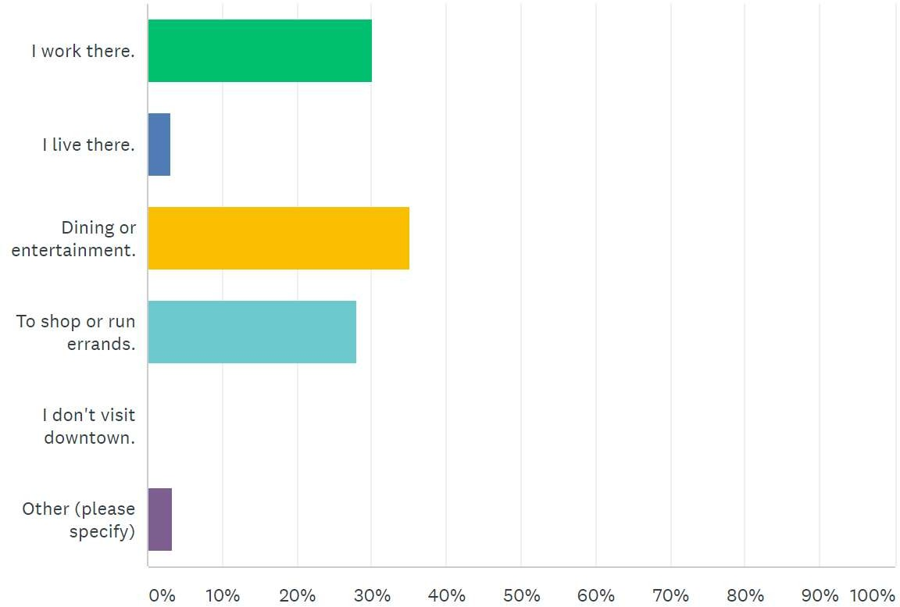

149

15

174

138

1

17

*Note: The City received several comments on this question. Many respondents preferred to answer “Multiple Reasons” or “All of the Above”. Additionally, many respondents come downtown to utilize the library. Below are the most common responses that were listed under “Other”:*

* + *Dining and shopping*
  + *Dining, shopping, and entertainment*
  + *Utilize the library*
  + *Dining, shopping, and utilize the library*
  + *Dining, shopping, and to attend meetings*

*Source: Survey Monkey, Walker Consultants, 2020*

Q3: On average, how much time do you spend looking for a parking space once you arrive in the downtown area?

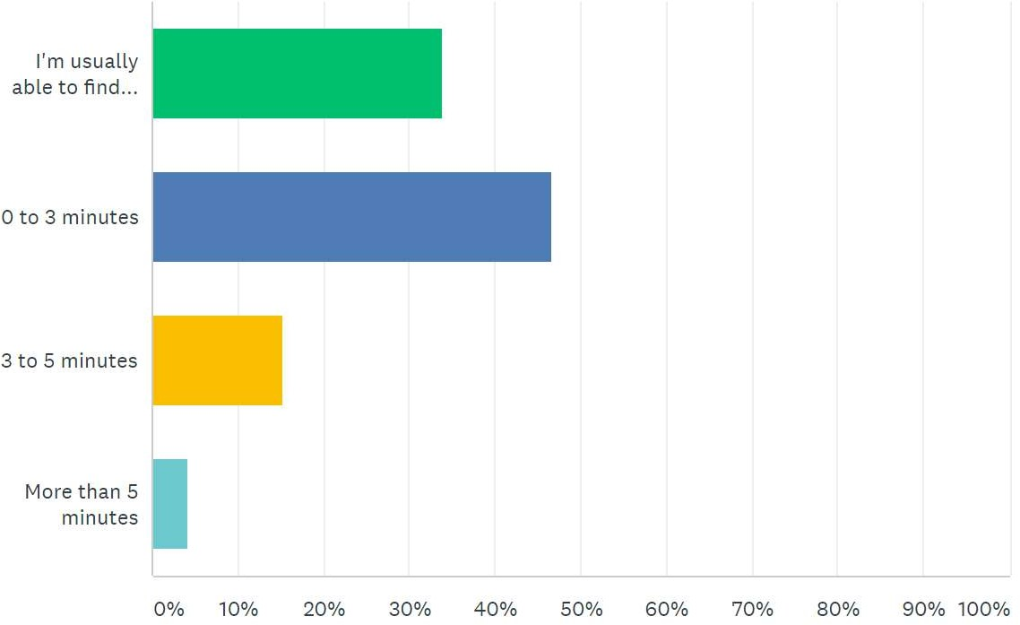

167

parking

immediately.

230

Over 80 percent of respondents (397)

reported finding a parking space either immediately, or under three (3) minutes. This is relatively fast for a downtown commercial district.

75

21

*Source: Survey Monkey, Walker Consultants, 2020*

Q5: How far from your destination are you typically able to park?

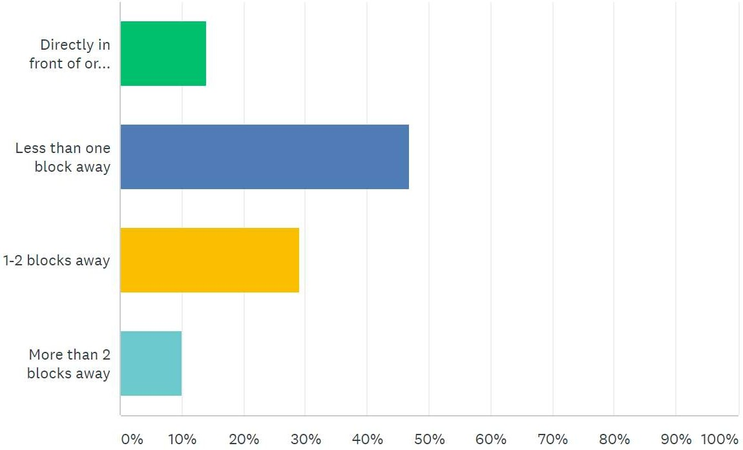

69

231

90 percent of respondents (433) reported

finding a parking space less than two blocks from their destination. This is considered within a customer Level of Service (LOS) “A” or “B”. A one-and-a-half block walk in downtown Houghton would be considered within LOS “A”, the highest possible customer level of service.

143

50

*Source: Survey Monkey, Walker Consultants, 2020*

Q20: Which of these parking/transportation types or practices do you think Houghton needs more of? (Multiple Answers)

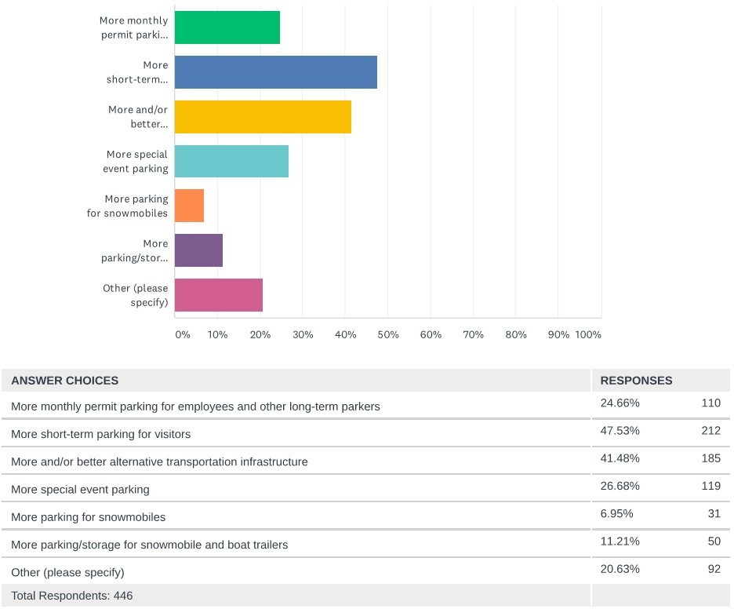

110

212

185

119

31

50

92

*Source: Survey Monkey, Walker Consultants, 2020*

Q21: Please share your level of support for time-limited on-street parking.

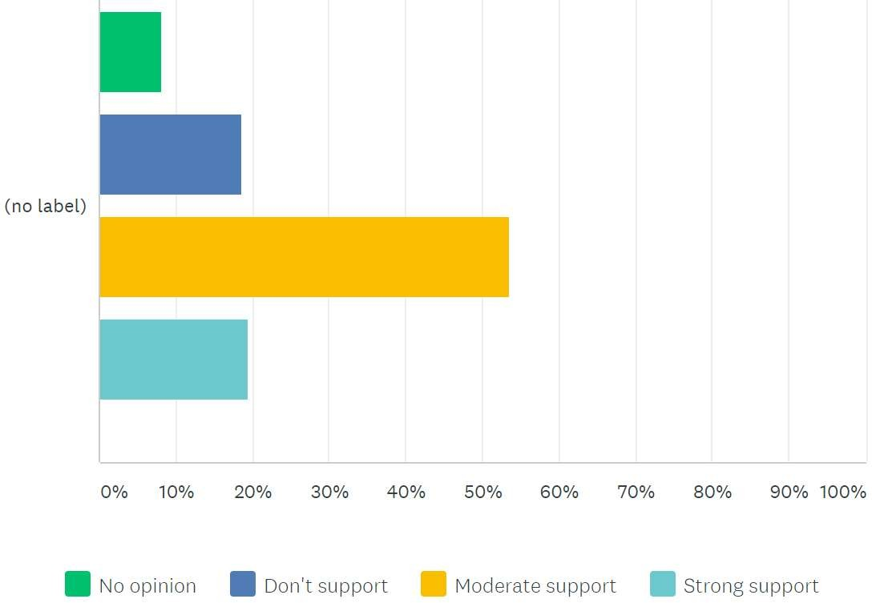

39

90

258

94

*Source: Survey Monkey, Walker Consultants, 2020*

*ADDITIONAL KEY SURVEY FINDINGS*

* 92 percent of respondents arrive in downtown Houghton via personal vehicle. Six (6) percent walk to downtown, and two (2) percent use a variety of transportation means (personal vehicle, walking, biking). Zero (0) respondents utilized Houghton Public Transit or Michigan Tech. Shuttle services.
* Approximately 60 percent of respondents prefer to park in the Big Deck.
* 72 percent of respondents said proximity to their destination is the most important factor when deciding where to park on both a typical day and during a special event.
* 35 percent of respondents indicated the amount of available parking downtown does not influence their decision to visit downtown.
* 84 percent said the availability of parking downtown is “adequate” or “good”.
* 37 percent indicated parking during special events is “inadequate”.
* 50 percent responded saying alternative transportation options are “inadequate”.
* 53 percent do not support time limits for off-street parking.

RECOMMENDATIONS

While there are localized areas of downtown Houghton that experience higher levels of parking demand, the overall supply exceeds demand within the downtown area. The public parking system in downtown Houghton is a network of resources and policies designed in partnership with the community to provide citizens, visitors, and businesses equitable access to goods and services. The public parking system is designed to support economic development initiatives by connecting people and places. As the community changes over time and old land uses are repurposed, and the popularity of new destinations rise and decline, the public parking system must allow for flexibility. While the quality of the parking system may be perceived based on an isolated surplus or shortfall, the performance metrics used to determine the effectiveness of the parking system to connect the community must include the measurement of the overall downtown mission. The parking system performance is the result of policy governance that focuses on metrics and monitors the overall quality of service, customer experience, and operational governance that values citizen safety and accessibility.

Each downtown citizen, visitor, and employee may have different expectations of acceptable walking distances, time restrictions, and accessibility based on the type of parking they select, short- or long-term. On-street spaces in core areas should turnover frequently, allowing for retail and customer short-term parkers, while off-street spaces in peripheral areas should allow for longer durations of stay and cater more towards Michigan Tech students, employees of downtown businesses, and residents. The following recommendations are based on current and historical metrics, operation and policies, public observations and comments gleaned from the virtual meetings and the online survey, and input from City staff.

INCREASE EFFICIENCY THROUGH SHARED PARKING

Existing, publicly accessible parking spaces and facilities should be utilized as efficiently as possible, in order to delay the City having to build additional public parking if the need ever arose. This means encouraging more employees, patrons, and visitors to make use of the surface lots, ramps, and on-street spaces located south of Shelden Avenue and on the west end of downtown (particularly the Ambassador Ramp and the small surface lots near the intersection of Shelden Avenue and Memorial Drive). However, as parking demand grows in the future, there may be a need for additional parking inventory to serve downtown users. Ideally, prior to the City building more public parking facilities, more effective sharing of existing parking spaces can be used to satisfy the additional demand. It

is recommended that the City look to create arrangements with the owners of private parking facilities to allow for public use of these facilities at certain times of day.

Currently, like many downtowns across the country, private businesses in downtown Houghton control a significant portion of the existing parking inventory. Based on Walker’s surveys of the study area, nearly 31% of the spaces in downtown Houghton, or 487 out of 1,587 spaces, are privately-owned and/or are reserved for permit parkers. Parking in these facilities is intended for use by patrons and/or employees of certain businesses in downtown, with signage often indicating the parking restrictions in place. However, many of these businesses are only open during regular business hours on weekdays. This means that the parking facilities that serve these businesses can be significantly underutilized or nearly empty after business hours on weekdays and on the weekends.

For example, Michigan Tech has access to two permit-only parking lots at the Lakeshore Center (2B and 4A on the facility map) with a combined 106 parking spaces on the east side of downtown. While these facilities are highly utilized primarily during the daytime on weekdays, especially during meetings and events, in the evenings and on weekends these lots have significant available parking capacity. If downtown employees, patrons, and/or visitors could park in these facilities during off-peak times, that would create significant additional parking capacity in this high-demand area of downtown without the need to build more spaces. Further, when Michigan Tech’s lease for these lots expires in 2021, the City should use the opportunity to explore opening part or all of these spaces to public parking (or some form of shared use parking). Other examples of private parking facilities that are underutilized at certain times of the day exist throughout downtown Houghton.

In order to make better use of these existing parking facilities, the City should look to enter into formalized shared parking agreements with these private property owners. A shared parking agreement between a municipality and a private owner is used to identify the parking facility to be shared, the conditions under which the facility can be used for public parking (i.e. times of day, days of the week, etc.), and details the responsibilities of each party to the agreement. Often, a private owner will enter into a shared parking agreement in exchange for the municipality monitoring use of the facility, ensuring cars do not remain parked overnight, and cleaning up trash left by public parkers. In some cases, the private owner will seek monetary compensation to enter into a shared parking agreement or will require the municipality to contribute to facility maintenance, snow plowing, or other facility costs.

Depending on the terms, shared parking agreements can be an effective way for a municipality to add parking capacity to their system without the significant costs associated with building additional facilities.

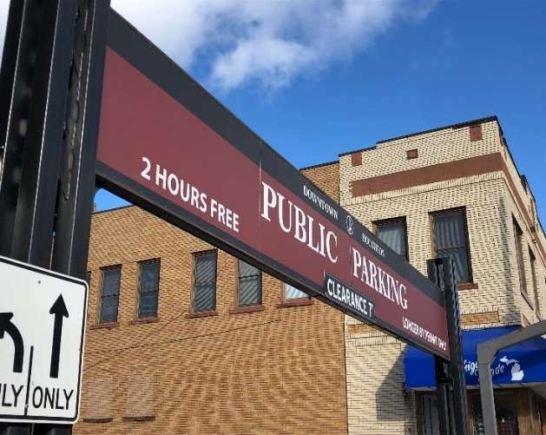IMPROVE WAYFINDING SIGNAGE

Based on Walker’s observations of parking demand and input received from the stakeholder meetings, there is almost always available parking in downtown Houghton on the same block or within one block of any destination. However, at times, especially for occasional visitors and tourists, it can be difficult to find the public parking facilities. While the signage located at the entrances to the public parking facilities is generally clear and highly visible (as shown in the inset picture), wayfinding signage leading into downtown that directs drivers to parking is less prominent.

To improve the ease with which infrequent visitors to downtown Houghton can locate the off-street public parking facilities, Walker recommends the City:

* Identify potential locations along U.S. Route 41 and M-26 for wayfinding signage directing drivers to its public parking facilities.
* Work with the State of Michigan regarding the potential sign locations and installation of these wayfinding signs.
* Lobby the State to waive their signage design requirements in this instance in order to save on the cost of the signs.
* If the State is uncooperative, identify alternate sign locations along the main driving routes into downtown that will not require the State’s approval including Bridge Street, Portage Street, and Lakeshore Drive.

Given the minimal nature of these additional wayfinding signs (examples of which are shown below), it is our hope that the State of Michigan will be open to placing the signs along the major routes into downtown. However, based on discussions with City staff, it may be necessary to find alternative locations for these signs due to the State’s signage requirements and the potential costs of meeting those requirements.

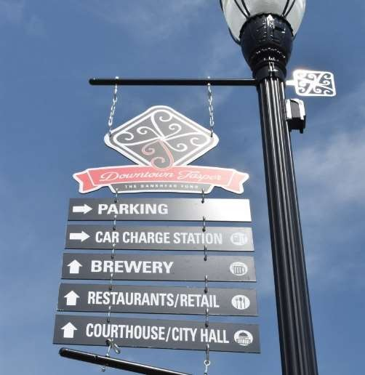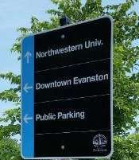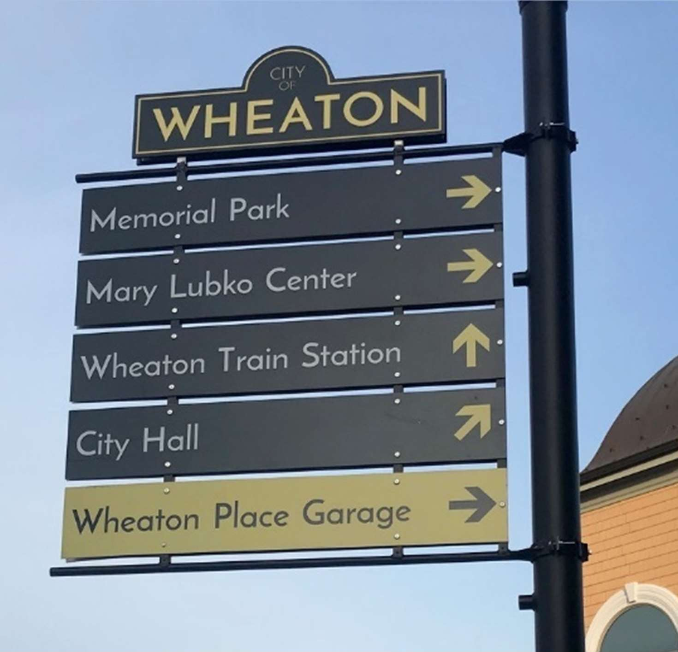

Should the State prove to be too difficult to work with or if suitable alternate locations for additional wayfinding signage cannot be found, recommended improvements to the parking information on the City’s website should also improve visitor’s ability to locate parking in downtown.

INCREASE AVAILABILITY OF VISITOR PARKING INFORMATIOIN

In addition to consulting online sources for restaurant recommendations and points of interest, people visiting a city for the first time will also often look online for parking information. Providing easily accessible and clear parking information online can greatly reduce the stress experienced by first-time or infrequent visitors to a city. At present, information about public visitor parking in downtown Houghton is not easy to find online.

If you use Google to search for “Houghton MI Parking”, the first result is the City’s main website and the next several results all relate to the City’s winter parking ban. Once on the City’s website, it is straightforward to navigate to the “Police & Parking Enforcement” page. However, once there, two sentences near the bottom of the page describe the visitor parking accommodations in downtown, sandwiched between headings for “Parking Permits” and “Parking Tickets”. While additional signage on the approaches into downtown would help visitors navigate to the

City’s public parking facilities, improving the parking information available on the City’s website can also help serve the same purpose.

By providing additional information on the City’s website, such as a map of public parking locations with restrictions identified and information regarding Day Permits, visitors to downtown Houghton will feel more comfortable finding a place to park when they drive into town. Additionally, providing this information can improve utilization of the City’s existing off-street facilities and on-street spaces by occasional visitors who might think that the Big Deck and Shelden Avenue are the only places to park.

Below are a few examples of parking maps for smaller municipalities that effectively communicate where public parking is available in relation to points of interest in the various downtowns.

Figure 5: Holland, Michigan Online Parking Map

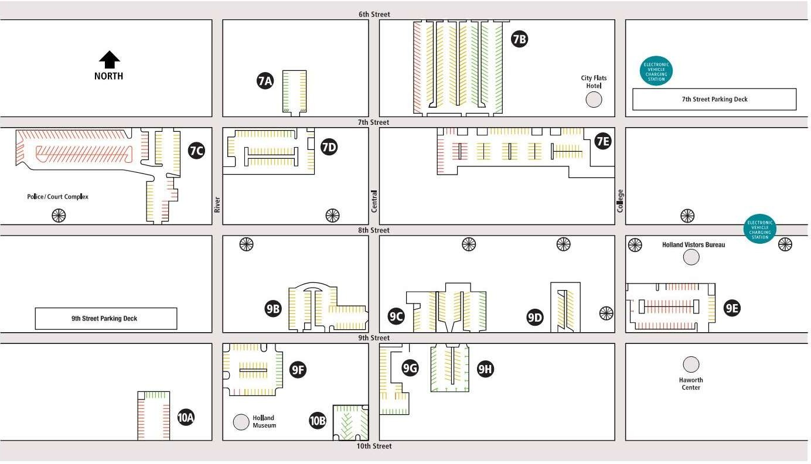

*Source: City of Holland, 2020*

Figure 6: Petoskey, Michigan Online Permit Parking Map

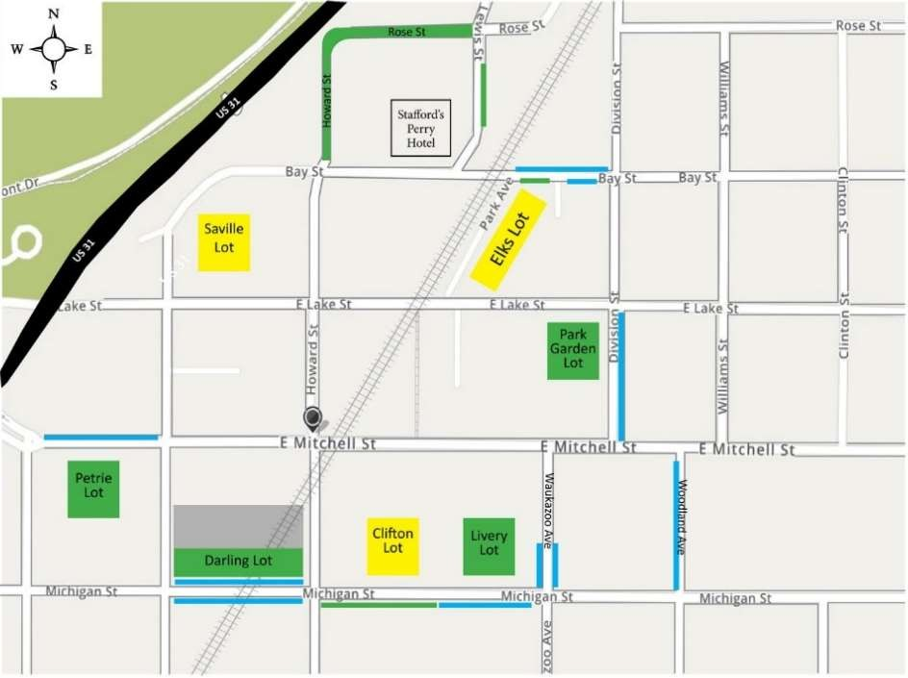

*Source: City of Petoskey, 2020*

Figure 7: Harrisonburg, Virginia Online Parking Map

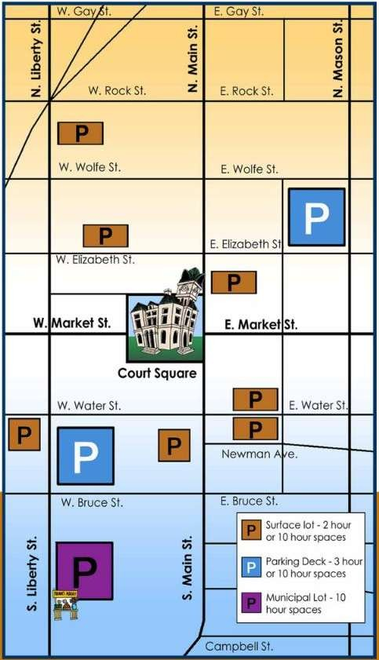

*Source: City of Harrisonburg, 2020*

CREATE UNIFORMITY IN ON-STREET TIME LIMITS

Presently, on-street parking on Shelden Avenue is restricted to a one-hour time limit, while the remaining streets with time-limited parking allow cars to remain in the same space for two hours. In both cases, these spaces are intended to serve short-term visitors to downtown such as restaurant patrons, shoppers, and people running errands. However, one-hour may not be enough for someone having a leisurely meal or someone eating in a restaurant and then running other errands on the same trip. Additionally, having two different time limits in place on adjacent streets in downtown could cause confusion for occasional visitors. Finally, multiple time limits make it more difficult to enforce than if all the streets shared a common time limit.

For all the above reasons, Walker recommends that the City implement a uniform, two-hour time limit across all timed on-street parking spaces in downtown. Two hours of parking should provide ample time for most visitor’s trips into downtown, without making people feel rushed to move their cars for fear of receiving a ticket. Additionally, in most instances, a two-hour limit should prevent downtown employees from parking in a timed space and moving their cars multiple times per day, as opposed to buying a permit or parking in a long-term space off-street. For visitors who need additional time, longer-term off-street parking options are available at peripheral surface lots.

The one exception to Walker’s recommendation of uniform on-street time limits in downtown relates to loading/unloading spaces along Shelden Avenue. A concern specifically voiced by the participants in the stakeholder meetings was the lack of convenient spaces dedicated to patron/customer loading and unloading. While there are commercial loading zones along Lakeshore Drive under the Big Deck, there are no spaces in the City’s public off- street facilities or on-street set aside specifically for quick patron/customer loading and unloading. If a parker is lucky enough to locate a public space near the store they are patronizing, loading/unloading can be convenient. However, if the closest spaces are taken, loading/unloading is much more difficult. For this reason, Walker recommends that the City dedicate one space per block on the north side of Shelden Avenue as a 15-minute, non- commercial loading zone. These spaces are intended to serve only very quick trips into downtown, providing a short-term, high-turnover parking option to aid customer loading and unloading activities.

DOWNTOWN WALKABILITY AND DENSITY

In economically vibrant downtowns and commercial districts throughout the country, building and land use development density are preferred over an abundance of underutilized or partially vacant surface parking lots and decks. Downtown patrons may have to walk slightly farther to get to and from their vehicle to their destination, but this sidewalk traffic contributes to a healthy downtown pedestrian ecosystem and promotes economic activity. As mentioned earlier, in a downtown commercial environment, sharing the available parking assets (shared parking) allows for the highest and best use of the existing parking supply. This shared parking demand management strategy allows for the sharing of parking spaces among uses in a commercial district mixed-use environment – in lieu of providing a minimum number of parking spaces for each land use. It is defined further as the ability to use the same parking resource by multiple nearby or adjacent land uses without encroachment. This efficient use of public parking and the citizen-centric approach to providing a level of service choice helps the City maximize the use of public resources.

Downtown visitors, customers, and employees each have a unique perception of what is an acceptable parking location in relation to their destination. Employees are typically more willing to park farther away, while visitors and customers desire access to the most proximate parking available.

Primary Factors Contributing to Walkability in Houghton

* Spacious and unobstructed sidewalks and pedestrian crosswalks
* Safe street designs that separate pedestrians and vehicles
* Interesting building stock with vibrant and active ground-level businesses
* Timely and effective snow removal
* Pleasant and active waterfront

Some can view suburban or regional shopping destinations as direct competition to downtown shopping districts. Customer and employee access to free parking, along with the volume of products and services offered within a shopping center, are often identified as potential competitive advantages. While people often highlight these attributes as advantages of suburban shopping centers over downtowns, the sense of convenient access at suburban shopping centers often differs from reality.

At the Walmart on M-26 southwest of downtown, it is approximately 620 feet from one end of the store to the other. A patron may walk this distance in less than two (2) minutes. Similarly, 620 feet equates to approximately two city blocks in downtown Houghton. The entirety of downtown Houghton (east of the Lift Bridge, north of Houghton Avenue, and west of Franklin Street) is within 620 feet, or two city blocks, of any public off-street parking facility in downtown. This equates to approximately 1/10 of a mile, and less than a two-minute walk. Figure 8 and Figure 9 provide a visual representation of walking distances at both the suburban Walmart and in downtown.

Figure 8: Walmart Walking Distance

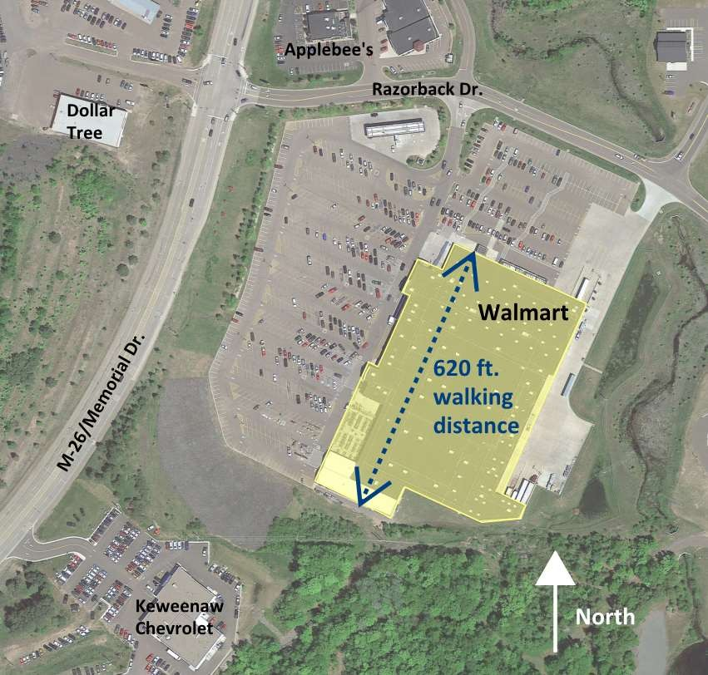

*Source: Google Earth, Walker Consultants, 2020*

Figure 9: Downtown Walking Distances from Public Parking Locations

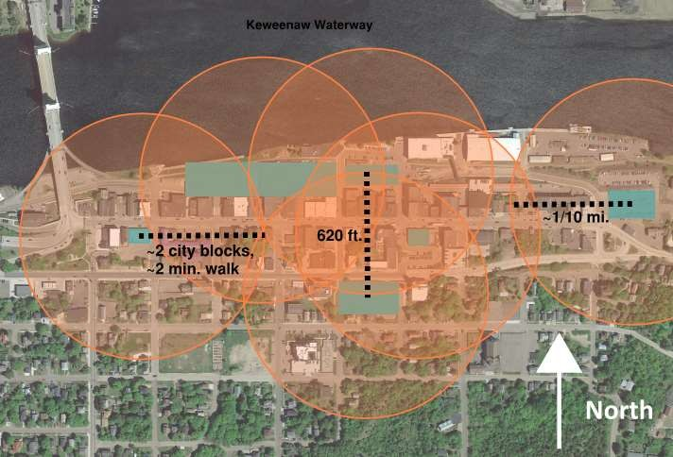

Public Parking

**Legend**

*Source: Google Earth, Walker Consultants, 2020*

Walker understands crossing Shelden Avenue can be difficult/dangerous when accessing parking supply to the south. If pedestrian crossing improvements and/or vehicle speed-reducing measures are installed, this would enhance Houghton’s already favorable walkability and pedestrian friendliness, as well as increase the ease of access to the parking supply and other attractions south of Shelden.

Based on the convenient walking distances and scale of downtown Houghton, Walker recommends that the City continue to promote walkability and high level of service walking distances in and around its downtown. Signage and maps can be changed to reflect walking distances and times. Further, additions and revisions can be made to the City’s website to provide walking distance and time information from City Center and the waterfront to various points of interest, including public off-street parking facilities.

EMPLOY TECHNOLOGY FOR ENFORCEMENT OF TIME LIMITS AND PERMIT PARKING

In order to be effective in creating vehicle turnover, posted time limits should be monitored and enforced. The City of Houghton currently manually enforces parking time limits and permit parking through visual verification of where vehicles are parked and for how long. For time-limited parking, the City’s enforcement officer documents how long a vehicle has been parked in a space by comparing a series of time-stamped pictures on a smart phone. The same enforcement officer also visually verifies that all vehicles parked in permit spaces are displaying the proper permit. While this method of enforcement is effective, it requires a person to walk the downtown several times per day in all weather conditions in order to enforce the parking regulations. Additionally, the manual nature of the enforcement process does not allow the City to gather much data related to parking trends, space utilization, employee parkers shuffling cars between time-limited spaces, or other parking conditions in downtown Houghton.

Through technology, the City can dramatically improve the efficiency of its enforcement operation, in addition to gathering valuable utilization data that can be used to make future decisions and long-term plans related to the

downtown parking system. Mobile License Plate Recognition (LPR) systems use vehicle-mounted cameras to scan and document the license plates of vehicles parked along streets and in off-street parking facilities. These scans include time and location codes that are compared to the existing parking restrictions in order to identify vehicles that are in violation. A computer mounted inside the vehicle records the data, GPS position, and checks the data to determine if the vehicle was previously parked and determine the length of stay. Additionally, the data gathered can be used to identify vehicles that are being shuffled among time-limited spaces, but that are never parked in violation of a maximum time limit for one space. Further, plates can be compared to a database of permit parkers or list of wanted vehicles for other violations and additional corrective action.

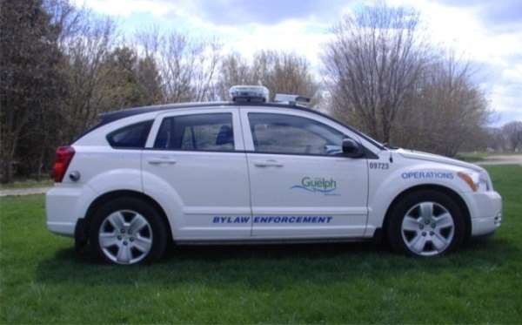

NuPark, AIMS, Genetec, and Tannery Creek Systems are examples of firms that offer a vehicle mounted LPR system that include special vehicle mounted cameras and software to capture the plate and vehicle location. As an advanced option, some systems can capture the wheel stem location as the enforcement vehicle drives past the parked vehicle.

Our opinion of base cost for one LPR vehicle-mounted

system is $35,000 - $45,000, plus the cost of the vehicle. The systems can be deployed on most regular passenger vehicles

Parking enforcement vehicle with cameras highlighted in

Guelph, Ontario.

and pick-up trucks and even specialized golf cart-sized enforcement vehicles. In addition to the initial base cost, there are on-going fees for cloud-based services, software updates, and database support.

Another option is to use handheld electronic devices to manually scan each plate and allow the enforcement officer to verify the plate number. Handheld systems typically cost about $5,000 per unit plus an on-going fee for cloud- based services and software updates. Leasing this type of system may be an option, which greatly reduces the initial investment and is based on the number of units in service.

Despite the cost associated with this technology, this type of system would allow the City of Houghton to effectively and efficiently enforce its existing parking regulations without the need to implement other facility controls or parking rates. This improved enforcement will help to ensure that time-limited spaces are being used appropriately and that downtown employees and residents are not inappropriately using parking intended to serve the City’s visitors and tourists.

OVER-SIZED PARKING FOR TRAILERS

It was brought to Walker’s attention that parking trailers for boats in the summer (and occasionally for snowmobiles in the winter) can be a challenge. There are likely a number of large surface lots at Michigan Tech and to the west along M-26 near the big box stores that could satisfy the space needs for these trailers. If the City identifies any locations outside of downtown that are viable, they could negotiate with each entity and direct visitors to those locations. However, since there is no shuttle service back to downtown, people would need to make their own arrangements to get back to downtown after parking their trailers.

Another potential solution is for the City to reserve and sign the entirety of the surface lot under the Lift Bridge for trailer (boat/recreational vehicle) parking-only in the summer months. The City should also continue to advertise this lot for over-sized parking in the winter for snowmobile trailers. Further, adding signage along Shelden Avenue directing oversized parkers to this lot will aid in the marketing and usefulness of the lot. The City should also continue to discourage RV’s from parking on Shelden Avenue due to safety and traffic visibility concerns. Having an

over-sized vehicle parking option in a central, downtown location is a rarity and is one of the many assets of downtown Houghton. Based on Walker’s parking demand analysis, there are numerous other places in downtown for traditional-sized vehicles to park, while encouraging more people to park at other downtown locations and walk to the waterfront may inspire more shopping, dining, etc.

OPERATING METHODOLOGY FOR A POTENTIAL WATERFRONT PARKING DECK

Should a mixed-use development along downtown Houghton’s waterfront be constructed, a new parking deck would serve a variety of new and existing land uses. As a replacement for the Big Deck, the facility would serve patrons of existing downtown businesses, current employee and resident parkers, and downtown visitors. Additionally, potential hotel, residential, and restaurant components of the development itself will create new groups of parkers who will use the deck. Due to the varying demands of these different parking user groups, several operating methodologies and technologies can be employed in a potential new parking deck in order to effectively serve all user-groups.

Residents of the new development will likely expect that there will be a reserved parking space for each unit, or a group of spaces reserved for only the development’s residents. This is common in downtown residential development projects of the type being proposed for downtown Houghton. To accommodate these parkers and ensure that non-residents do not park in resident spaces, it will likely be necessary to group or “nest” residential parking in an area of the deck. Often in mixed use developments with a residential component, these nested residential parking areas are located on the top level(s) of parking to provide convenient access from the deck to the residential units, as well as leaving the lower levels of the deck available for shorter-term public parkers. These areas can be controlled using rolling gates and/or parking equipment or be signed as “reserved” parking to prevent non-residents from using the spaces.

To control the remaining areas of the parking deck, it may be necessary to gate the facility to control access and monitor who is parking and how long they are staying. Guests of the proposed hotel are likely to need in and out parking privileges with access tied to a paid reservation at the hotel. Downtown visitors and patrons of local businesses will need access to the facility but are not likely to be allowed free, unlimited access at all times. Downtown employees who might purchase a permit currently and residents who park in the existing Big Deck during the winter months also have different needs than the other users of the deck. Technology can be used to effectively manage the use of the proposed deck by all user groups.

At present, the City’s parking facilities are signed to indicate the parking restrictions that are in place at a given facility. These regulations are then enforced by a City employee manually documenting compliance with the parking rules on an hourly and daily basis. Restricting access to the proposed deck using gates and requiring parkers to either purchase a permit or take a ticket at the entrance is a more effective way to manage the facility than posting restrictions on various spaces and enforcing those rules. While paid parking in the proposed deck may not be desirable, gating the facility would allow for more accurate tracking of parking utilization and increase availability of spaces through turnover, as well as the potential to collect revenue in the future. Alternatively, the first two (2) hours of parking could be free to transient parkers, similar to the other public parking decks in downtown, but any stay longer than that would require a small fee.

ADDITIONAL OPERATING ENHANCEMENTS FOR FUTURE CONSIDERATION

The above recommendations are intended to provide an immediate positive impact on parking in downtown Houghton. In addition, as new development occurs in downtown and parking demand grows and shifts in the future,

the City may benefit from other operational/technological changes. While the future characteristics of parking in downtown Houghton are unknown, the below operational and technological enhancements could be employed by the City in the future to address new issues that arise.

* Use Technology to Issue Day Parking Permits to Visitors – Parking kiosks, or pay-on-foot stations, installed in the City’s off-street public parking facilities can be used to issue Day Permits to downtown visitors, as opposed to visitors coming to City Hall to obtain a Day Permit. A variety of technologies exist at different price points that could perform this function.
* Create Seasonal Time Limits in Off-Street Facilities – If future changes in downtown demand patterns result in visitors remaining parked for long periods of time, it may be beneficial to adjust the time limits in the City’s off-street parking facilities. Lengthening the time limits in certain facilities during certain times of the year can provide visitors with more long-term parking options, reducing the number of people who receive a ticket for staying beyond the posted time limit. To avoid abuse of longer time limits by downtown employees and residents shuffling their cars throughout the day, this change would ideally be coupled with enforcement technology that can monitor usage by each vehicle (the LPR technology described above can perform this function).
* Implement Additional Wayfinding Technology – As downtown parking demand grows in the future it may be beneficial to enhance the City’s parking signage system to more effectively direct parkers to the City’s off-street facilities. Technology solutions exist that can dynamically monitor facility usage and provide this information to drivers via mobile applications, electronic signage, and online.
* Reintroduce On-Street Paid Parking – While on-street parking time limits can be an effective way to create parking space turnover, this method of control can also lead to abuse by parkers moving their vehicles throughout the course of the day, as opposed to parking in a long-term space off-street. The most effective way to reduce this abuse it to implement paid on-street parking. While not recommended at this time, the City may want to evaluate reintroducing paid parking (via pay-on-foot multi-space meters or self-service “kiosks”, and/or mobile application) on-street in downtown and in some or all of the public parking decks as demand increases in the future. This in order to keep the most convenient spaces available for short- term visitors and patrons of downtown businesses.

# APPENDIX – MUNICIPAL BEST PRACTICES

Wayfinding and Signage

Naperville, Illinois

* Automated Parking Guidance System (APGS)
* Electronic monitors displaying number of spaces available at each entrance

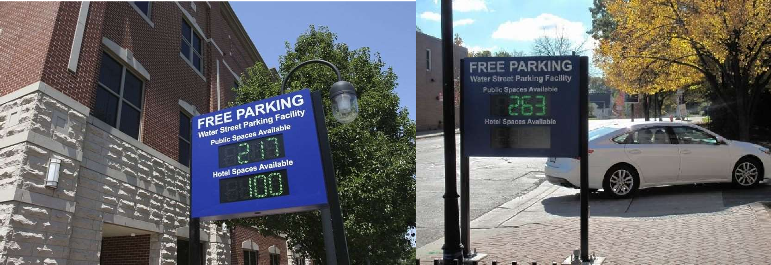

*Source: https://*[*www.dailyherald.com/apps/pbcs.dll/article?avis=da&date=20170719&category=news&lopenr=170719041&ref=ar*](http://www.dailyherald.com/apps/pbcs.dll/article?avis=da&date=20170719&category=news&lopenr=170719041&ref=ar)

Littleton, Colorado

* Downtown Wayfinding Signage
* Enhances the city, identifies an area, calls out points of interest, and increases pedestrian circulation
* Businesses can apply for placement on the signs and/or be featured on both sides of the sign. All businesses must meet certain criteria such as retail space size and hours of operation, and all businesses must be registered with the City’s Finance Department

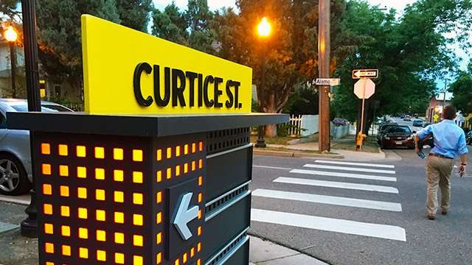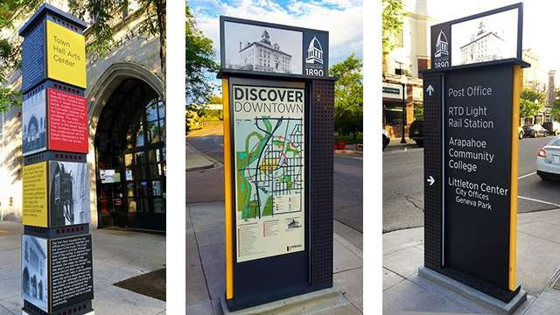

*Source: https://*[*www.littletongov.org/Home/Components/News/News/2107/*](http://www.littletongov.org/Home/Components/News/News/2107/)

Bike Share Program

Basalt, Colorado

* WE-cycle bike share program
* Funded through public/private partnership
* Allows for innovative solutions to transportation access in areas with limited public transportation and ridesharing/taxi services
* Basalt, CO population – 4,000

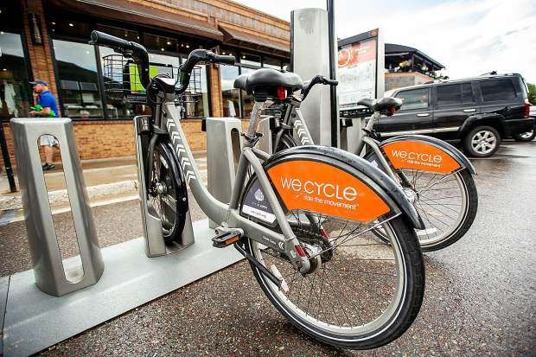

*Source: https://*[*www.aspentimes.com/news/aspens-bike-sharing-program-takes-off-in-first-free-year/*](http://www.aspentimes.com/news/aspens-bike-sharing-program-takes-off-in-first-free-year/)

Heated Sidewalks and Streets

Holland, Michigan

* Largest municipal snowmelt system in North America
* 6,000 square feet of tubing, totaling 4.9 miles and 10.5 acres of heated streets and sidewalks
* Water is circulated through 120 miles of plastic tubing by using waste heat
* The system can melt 1” of snow per hour
* Creates a vibrant walkable downtown throughout the year

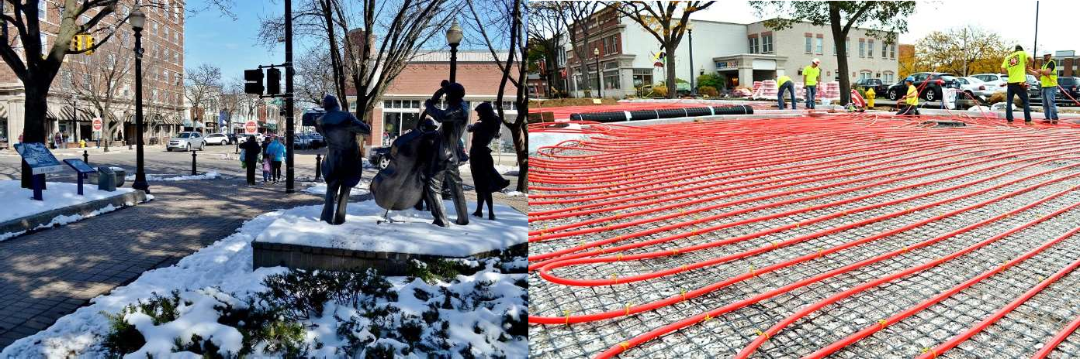

*Source: https://*[*www.holland.org/snow-free-holland*](http://www.holland.org/snow-free-holland)

# STATEMENT OF LIMITING CONDITIONS

This report and the conclusions and recommendations contained herein are subject to the following limiting conditions:

1. This report is based on some assumptions that are outside the control of Walker Consultants (“Walker”) and our client. Therefore, Walker does not guarantee the results.
2. The conclusions, projections, and recommendations presented herein may be dependent on future assumptions regarding the local, national, or international economy. These assumptions and resultant conclusions may be invalid in the event of war, terrorism, economic recession, rationing, or other events that may cause a significant change in economic conditions.
3. Walker assumes no responsibility for events or circumstances that take place or change after the date of our engagement.
4. All information, estimates, and opinions obtained from parties not employed by Walker are assumed to be accurate. We assume no liability resulting from the information presented by the client or client’s representatives or received from third-party sources.
5. This report is to be used in whole and not in part. None of the contents may be reproduced or disseminated in any form for external use by anyone other than our client without our written permission.
6. The projections presented in our analysis assume responsible ownership and competent management. Any departure from this assumption may have a negative impact on the results.
7. Computer models that use and generate precise numbers generate some of the Tables, Figures, and recommendations presented in this report. The use of seemingly exact numbers is not intended to suggest a level of accuracy that may not exist. A reasonable margin of error may be assumed regarding most numerical projections. Conversely, some numbers are rounded, and as a result, some results may be subject to small rounding errors.
8. This report was prepared by Walker, and all opinions, conclusions, recommendations, and projections expressed during the engagement period are rendered by the staff of Walker Consultants as employees, rather than as individuals.
9. This report presents some conceptual, financial information that is intended to provide an order-of- magnitude assessment of parking revenue, expenses, net income, and relative cost and is not to be used for financing purposes.